Assignment

- Extra Lab Practice For Database Concepts
1. Introduction to SQL
Lab 3: Create a database called library_db and a table books with columns: book_id,
title, author, publisher, year_of_publication, and price. Insert five records into
the table.
Answer:
- Create database and books table
Step 1: Create database
CREATE DATABASE library_db;
Step 2: Use the database
USE library_db;
Step 3: Create books table
CREATE TABLE books (
book_id INT PRIMARY KEY,
title VARCHAR(100),
author VARCHAR(50),
publisher VARCHAR(50),
year_of_publication YEAR,
price DECIMAL(6,2)
);
Step 4: Insert 5 records into books table
INSERT INTO books (book_id, title, author, publisher, year_of_publication, price)
VALUES
(1, 'Harry Potter', 'J.K. Rowling', 'Bloomsbury', 2001, 500.00),
(2, 'Lord of Rings', 'J.R.R. Tolkien', 'Allen & Unwin', 1954, 600.00),
(3, 'The Alchemist', 'Paulo Coelho', 'HarperCollins', 1988, 300.00),
(4, 'Pride & Prejudice', 'Jane Austen', 'T. Egerton', 2020, 250.00),
(5, 'Inferno', 'Dan Brown', 'Doubleday', 2013, 450.00);
Step 5: View records
SELECT * FROM books;
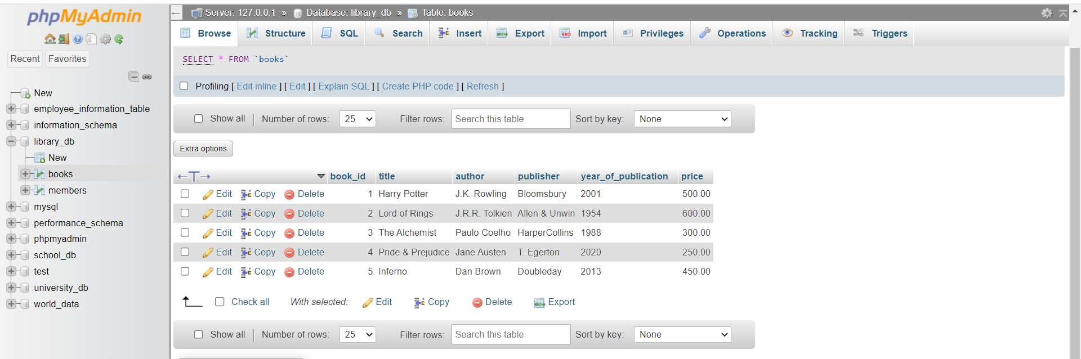

Lab 4: Create a table members in library_db with columns: member_id, member_name,
date_of_membership, and email. Insert five records into this table.
Answer:
- Create members table
Step 1: Create members table
CREATE TABLE members (
member_id INT PRIMARY KEY,
member_name VARCHAR(50),
date_of_membership DATE,
email VARCHAR(50)
);
Step 2: Insert 5 records into members table
INSERT INTO members (member_id, member_name, date_of_membership, email)
VALUES
(1, 'Alice', '2025-01-10', 'alice@example.com'),
(2, 'Bob', '2025-02-15', 'bob@example.com'),
(3, 'Charlie', '2025-03-20', 'charlie@example.com'),
(4, 'David', '2025-04-25', 'david@example.com'),
(5, 'Eva', '2025-05-30', 'eva@example.com');
Step 3: View records
SELECT * FROM members;
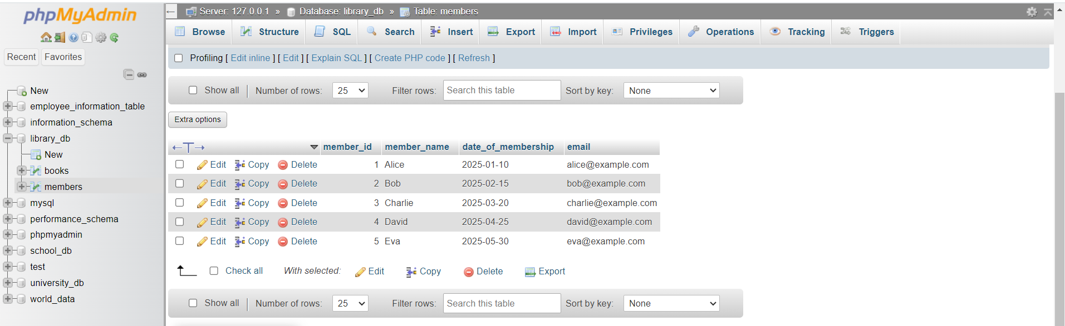
2. SQL Syntax
Lab 3: Retrieve all members who joined the library before 2022. Use appropriate SQL syntax with WHERE and ORDER BY.
Answer:
Query: Retrieve all members who joined the library before 2022
SELECT member_id, member_name, date_of_membership, email FROM members
WHERE date_of_membership < '2022-01-01' ORDER BY date_of_membership ASC;
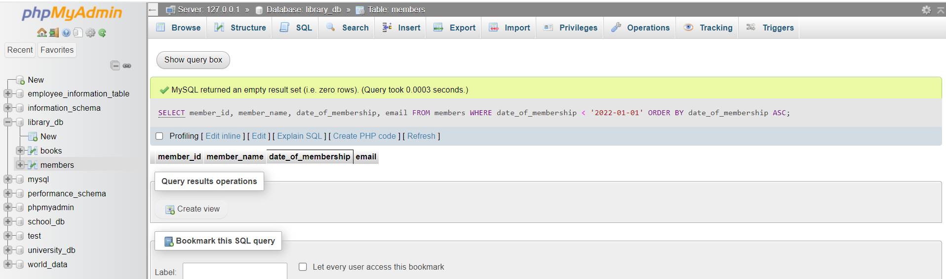
- These data have membership dates only in 2025, so no records – because no one joined before 2022.

Lab 4: Write SQL queries to display the titles of books published by a specific author. Sort the results by year_of_publication in descending order.
Answer:
Query: Display the titles of books published by a specific author (sorted DESC)
Example: Author – J.K. Rowling
SELECT title, author, year_of_publication
FROM books
WHERE author = 'J.K. Rowling'
ORDER BY year_of_publication DESC;
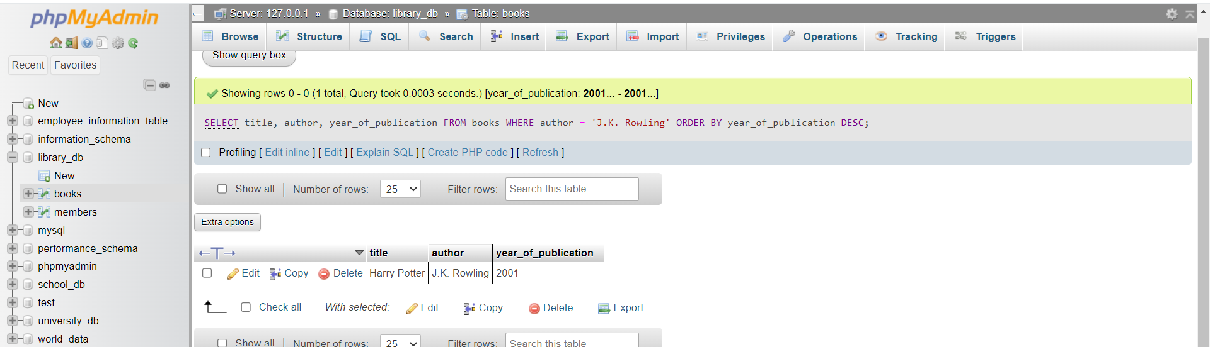

3. SQL Constraints
Lab 3: Add a CHECK constraint to ensure that the price of books in the books table is
greater than 0.
Answer:
Query: Add a Check constraint to ensure price > 0
ALTER TABLE books ADD CONSTRAINT chk_price CHECK (price > 0);
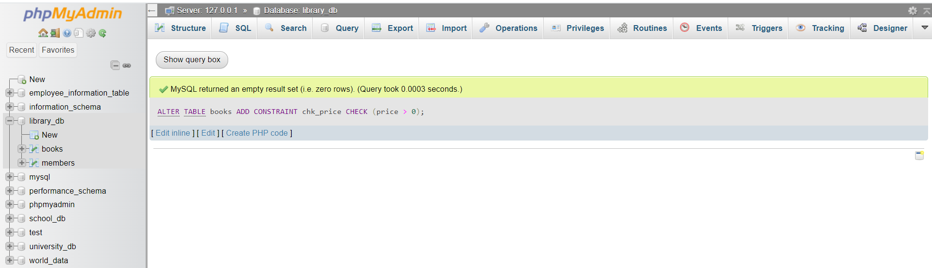
- This ensures price cannot be 0 or negative.

Lab 4: Modify the members table to add a UNIQUE constraint on the email column,
ensuring that each member has a unique email address.
Answer:
Query: Add UNIQUE constraint on email column in members table
ALTER TABLE members ADD CONSTRAINT unique_email UNIQUE (email);
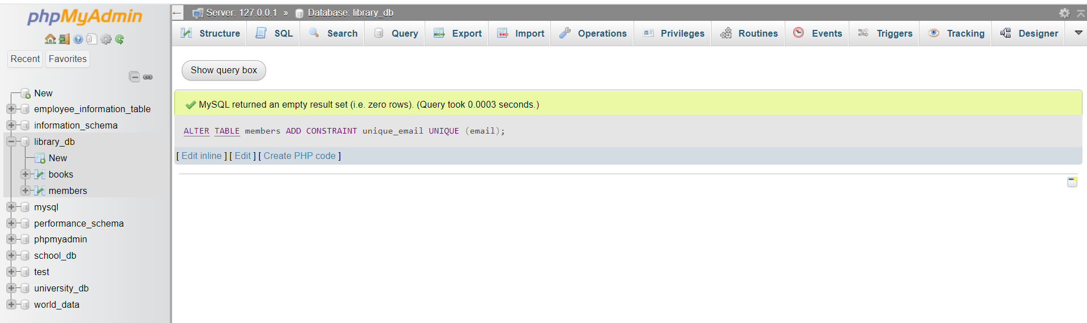
- This ensures no two members can have the same email.

4. Main SQL Commands and Sub-commands (DDL)
Lab 3: Create a table authors with the following columns: author_id, first_name,
last_name, and country. Set author_id as the primary key.
Answer:
Query: Create a Table
CREATE TABLE authors (
author_id INT PRIMARY KEY,
first_name VARCHAR(50),
last_name VARCHAR(50),
country VARCHAR(50)
);
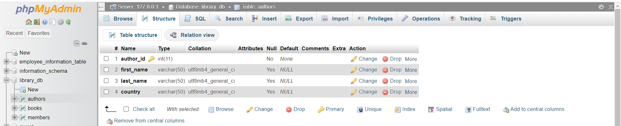

Lab 4: Create a table publishers with columns: publisher_id, publisher_name,
contact_number, and address. Set publisher_id as the primary key and
contact_number as unique.
Answer:
Query: Create a Table publisher with UNIQUE contact_number
CREATE TABLE publishers (
publisher_id INT PRIMARY KEY,
publisher_name VARCHAR(100),
contact_number VARCHAR(20) UNIQUE,
address VARCHAR(100)
);
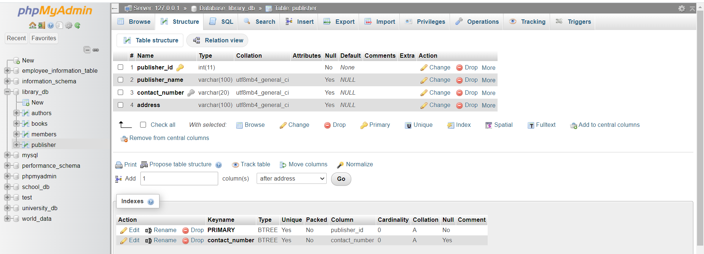

5. ALTER Command
Lab 3: Add a new column genre to the books table. Update the genre for all existing
records.
Answer:
Query 1: Add a new column genre to the books table
ALTER TABLE books ADD genre VARCHAR(50);
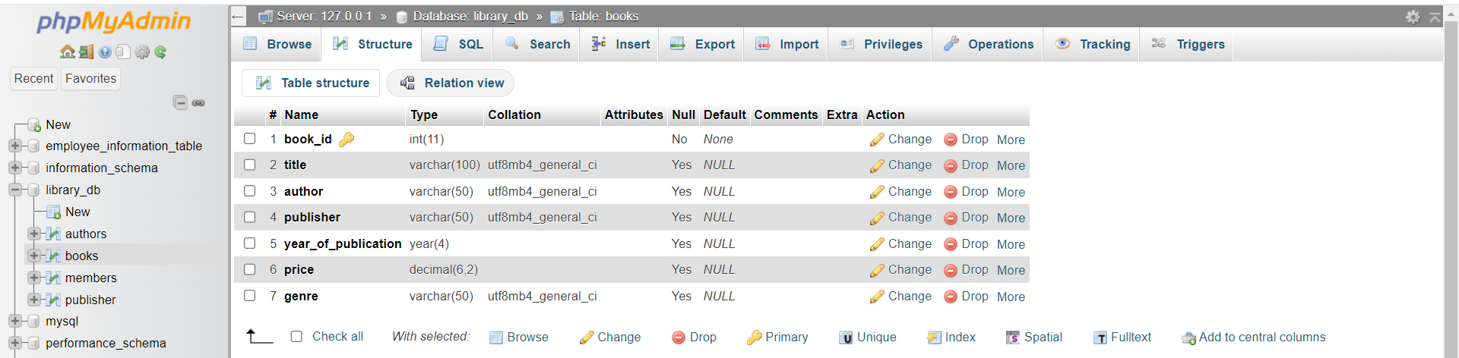

Query 2: Update genre for all existing books
UPDATE books SET genre = 'Fantasy' WHERE book_id = 1;
UPDATE books SET genre = 'Fantasy' WHERE book_id = 2;
UPDATE books SET genre = 'Fiction' WHERE book_id = 3;
UPDATE books SET genre = 'Romance' WHERE book_id = 4;
UPDATE books SET genre = 'Thriller' WHERE book_id = 5;
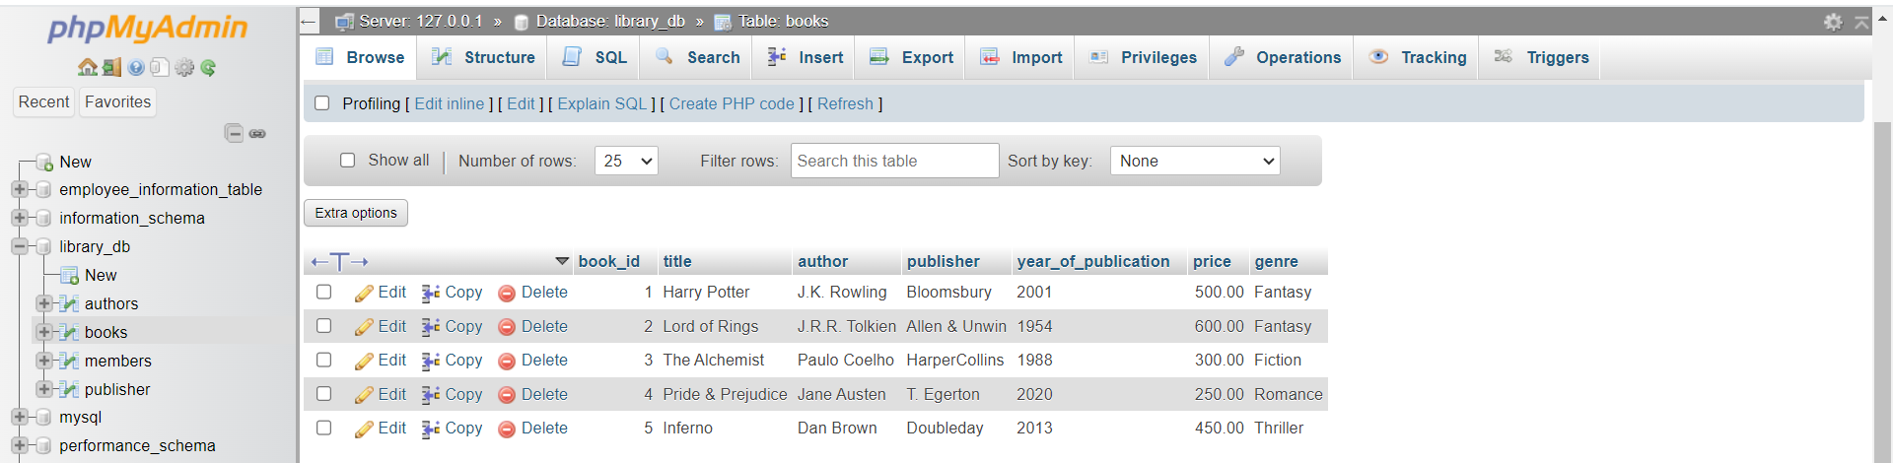

Lab 4: Modify the members table to increase the length of the email column to 100
characters.
Answer:
Query: Modify email length in members table to 100 characters
ALTER TABLE members MODIFY email VARCHAR(100);
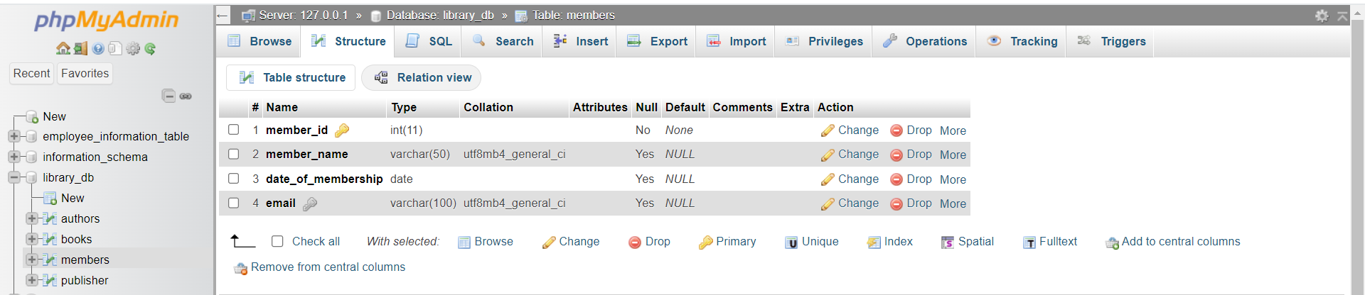

6. DROP Command
Lab 3: Drop the publishers table from the database after verifying its structure.
Answer:
Query 1: Verify table structure
DESCRIBE publisher;
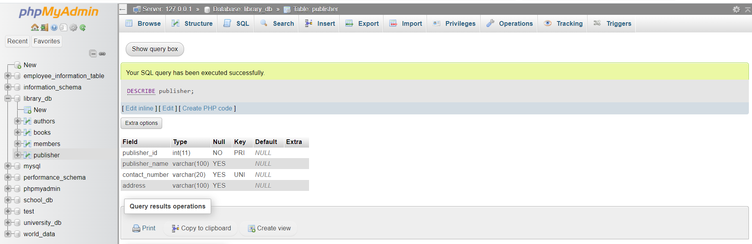

Query 2: Drop the table
DROP TABLE publisher;
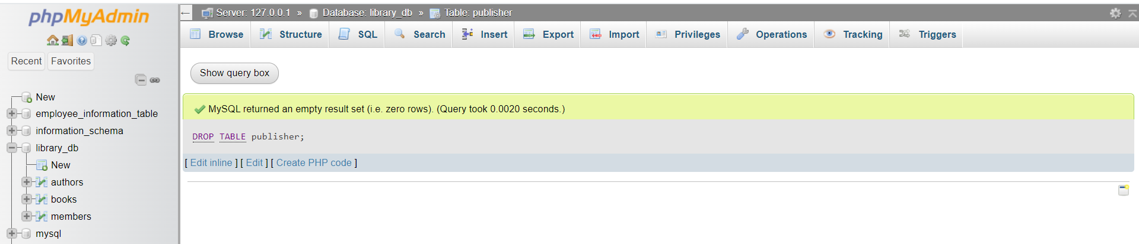

Lab 4: Create a backup of the members table and then drop the original members table.
Answer:
Query 1: Create backup table
CREATE TABLE members_backup AS SELECT * FROM members;
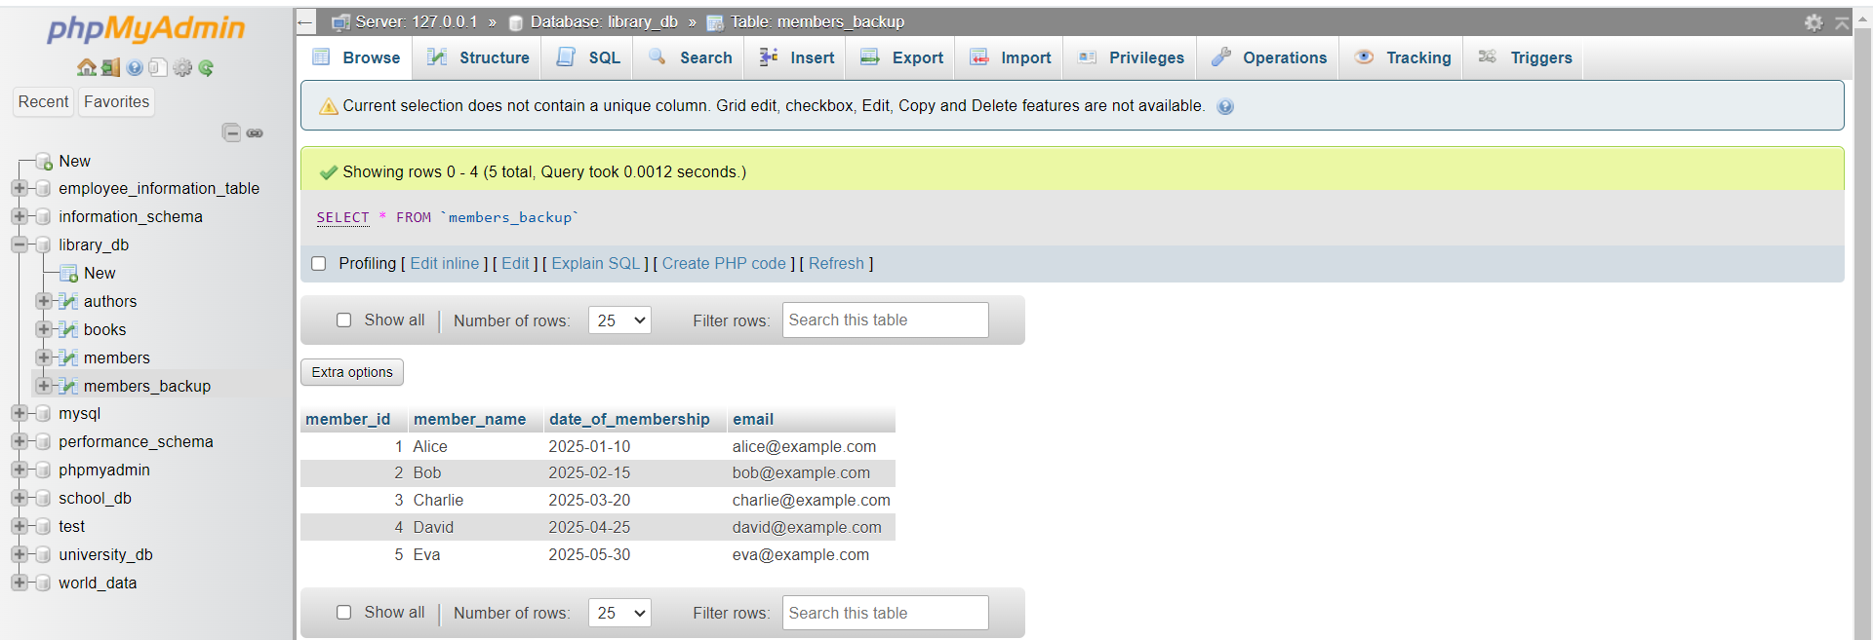
Query 2: Drop the Original Members table
DROP TABLE members;
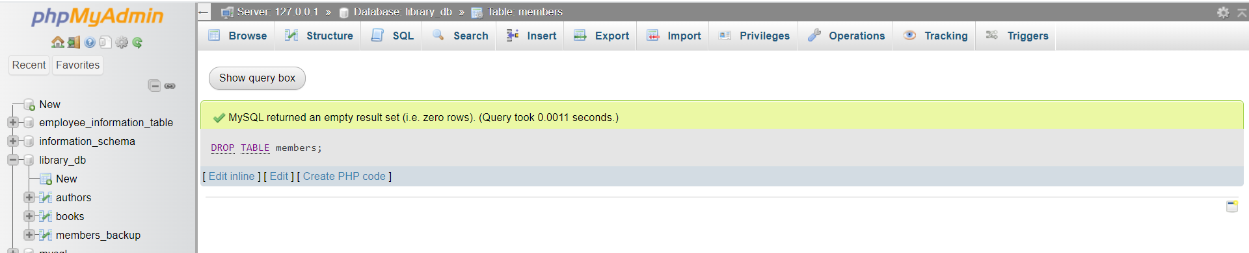

Query 3: View backup table (optional)
SELECT * FROM members_backup;
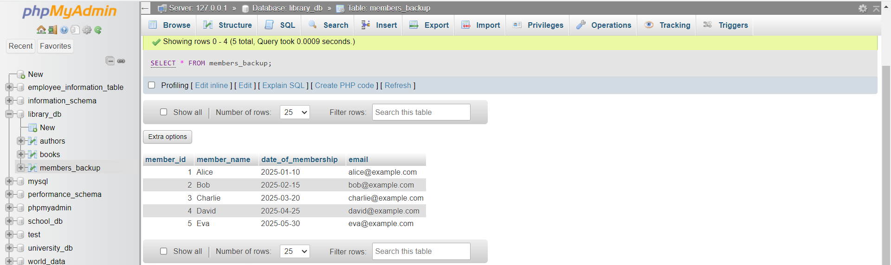
7. Data Manipulation Language (DML)
Lab 4: Insert three new authors into the authors table, then update the last name of one of
the authors.
Answer:
Query 1: Insert 3 authors
INSERT INTO authors (author_id, first_name, last_name, country)
VALUES
(1, 'George', 'Orwell', 'United Kingdom'),
(2, 'Mark', 'Twain', 'United States'),
(3, 'Agatha', 'Christie', 'United Kingdom');
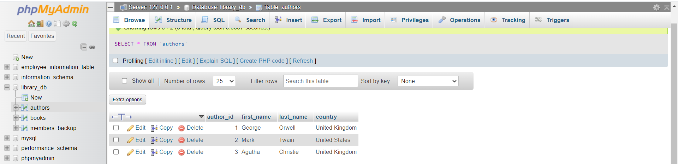

Query 2: Update last name of one author
Example: Change Mark Twain -> Mark Johnson
UPDATE authors SET last_name = 'Johnson' WHERE author_id = 2;
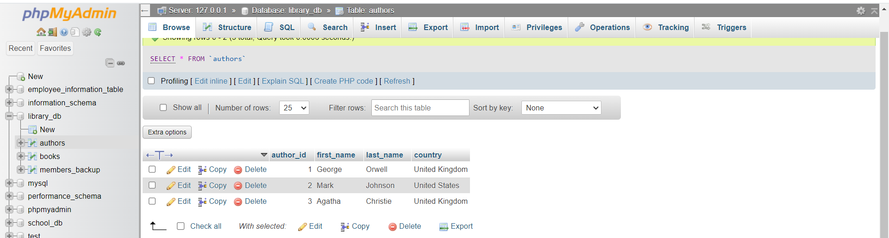

Lab 5: Delete a book from the books table where the price is higher than $100.
Answer:
Query: Delete a book where price > 100
DELETE FROM books WHERE price > 100 LIMIT 1;
- Based on data, all books have price > 100, so deleting any one book is valid.

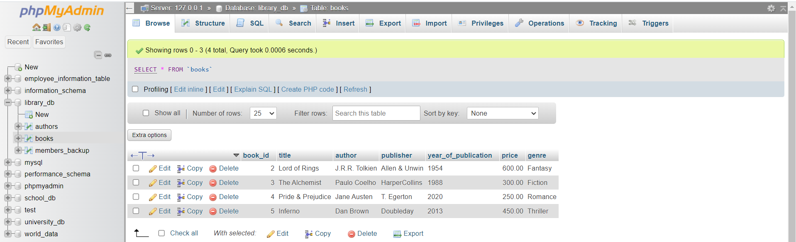

- Deletes only one book, even though many match.

8. UPDATE Command
Lab 3: Update the year_of_publication of a book with a specific book_id.
Answer:
Query: Update the year of publication of book_id = 3 (The Alchemist)
UPDATE books SET year_of_publication = 1990 WHERE book_id = 3;
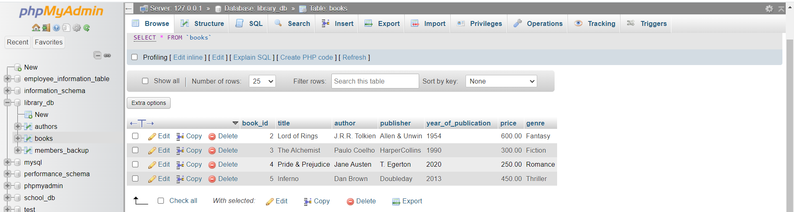

Lab 4: Increase the price of all books published before 2015 by 10%.
Answer:
Query: increase price of all books
UPDATE books SET price = price * 1.10 WHERE year_of_publication < 2015;
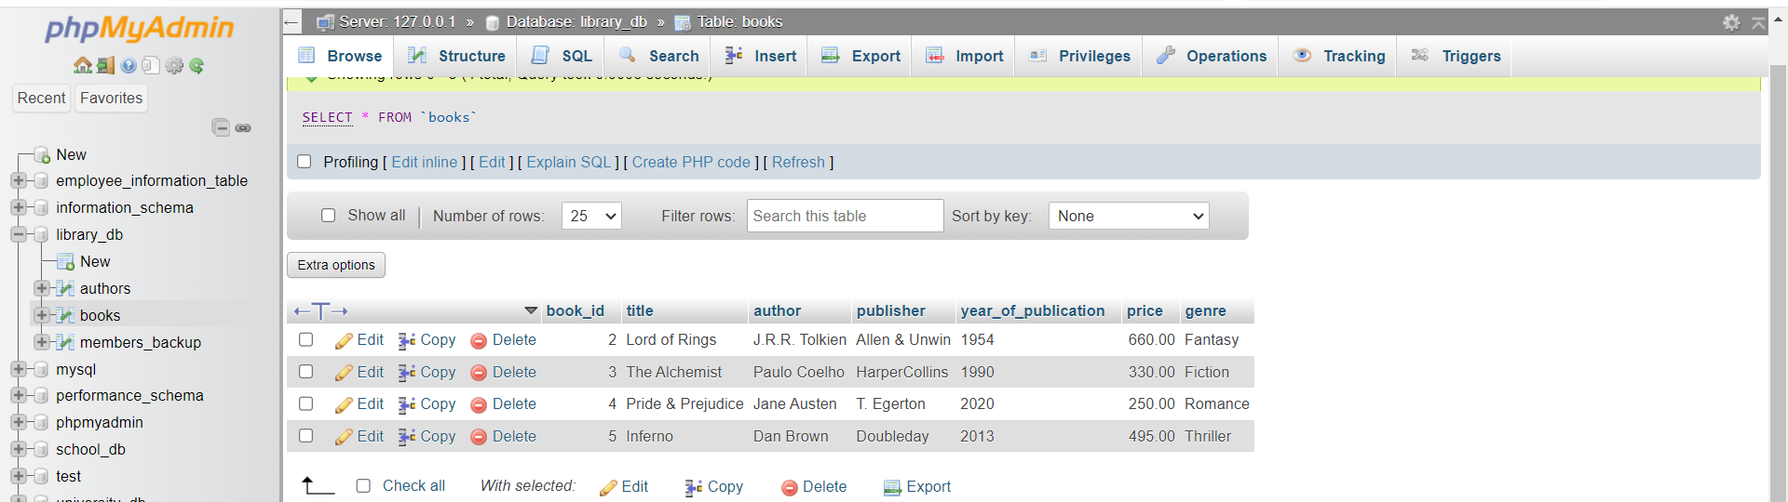

9. DELETE Command
Lab 3: Remove all members who joined before 2020 from the members table.
Answer:
Query: Remove all members who joined before 2020
DELETE FROM members_backup WHERE date_of_membership < '2020-01-01';
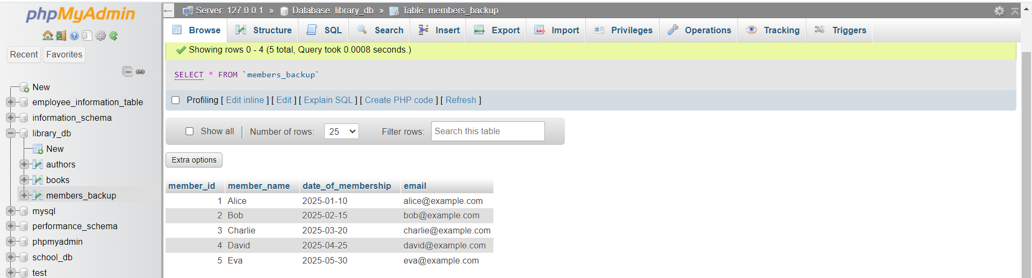
- In members table, all members are joined on 2025.
- All dates are after 2020, so no record will be deleted.

Lab 4: Delete all books that have a NULL value in the author column.
Answer:
Query: Delete all books with NULL author
DELETE FROM books WHERE author IS NULL;
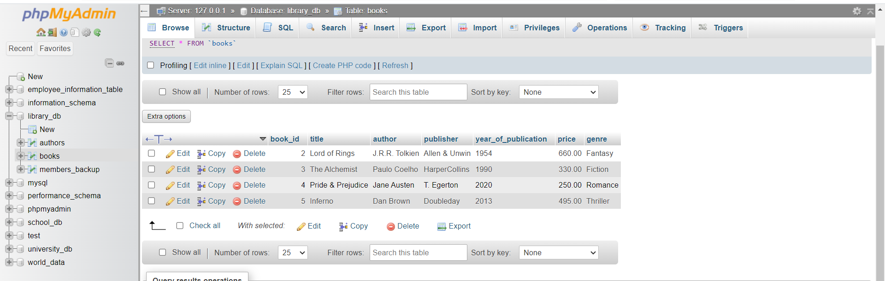
- In books table, all books have authors so no rows are deleted.

10. Data Query Language (DQL)
Lab 4: Write a query to retrieve all books with price between $50 and $100.
Answer:
Query: retrieve all books with price between $50 and $100
SELECT * FROM books WHERE price BETWEEN 50 AND 100;
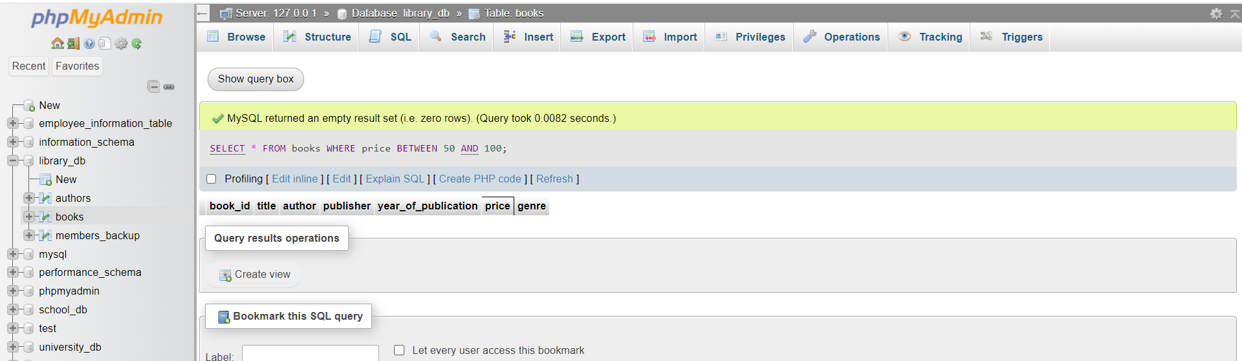
- None are between 50 and 100, so result is empty.

Lab 5: Retrieve the list of books sorted by author in ascending order and limit the results
to the top 3 entries.
Answer:
Query: Retrieve books sorted by author (ASC) and show top 3
SELECT * FROM books ORDER BY author ASC LIMIT 3;
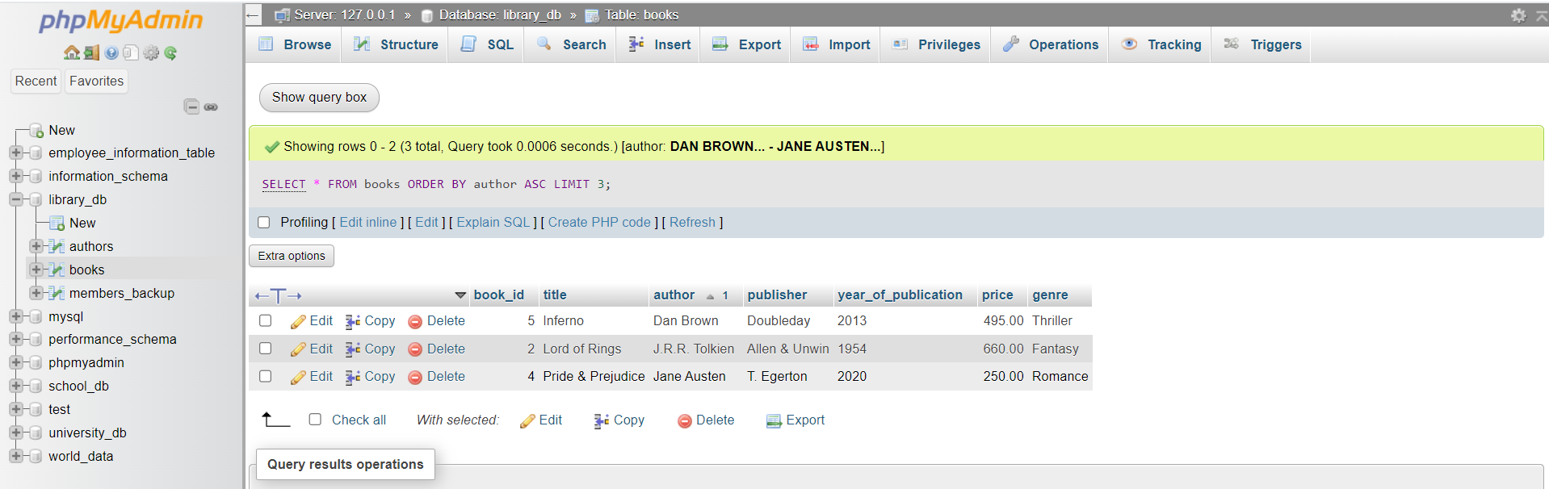

11. Data Control Language (DCL)
Lab 3: Grant SELECT permission to a user named librarian on the books table.
Answer:
Query: Grant SELECT permission to user librarian on books table
GRANT SELECT ON library_db.books TO 'librarian'@'localhost';
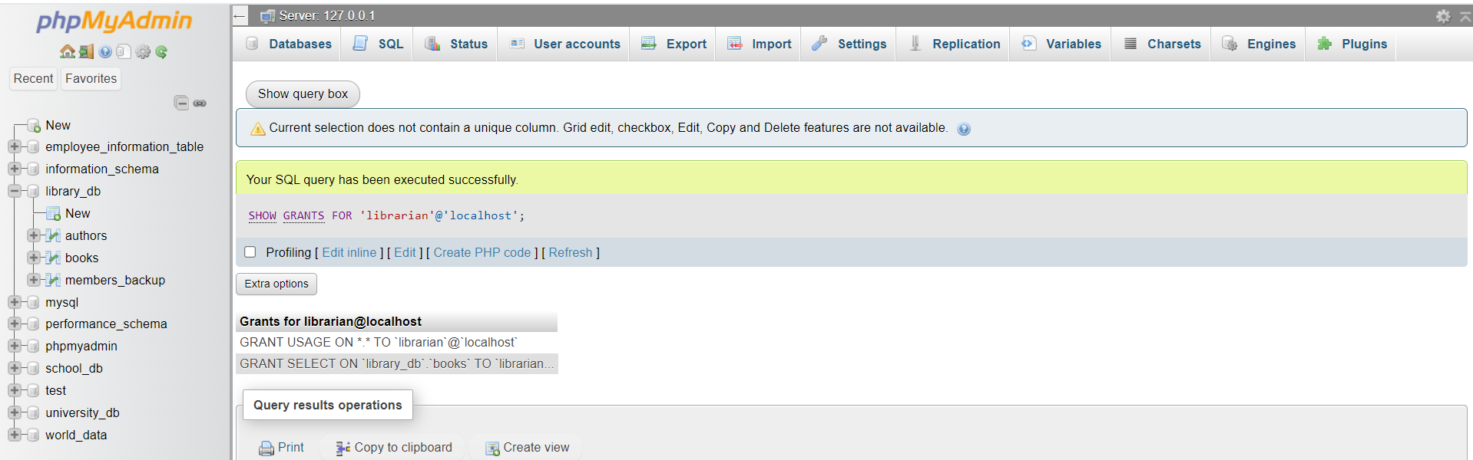

Lab 4: Grant INSERT and UPDATE permissions to the user admin on the members table.
Answer:
Query: Grant INSERT and UPDATE permissions to user admin on members table
GRANT INSERT, UPDATE ON library_db.members_backup TO 'admin'@'localhost';
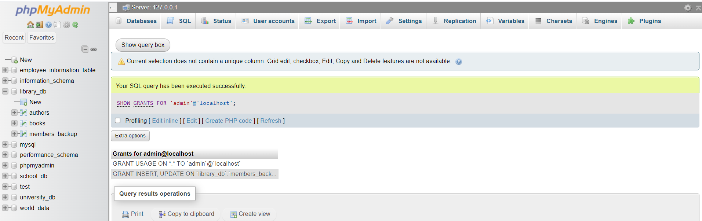

12. REVOKE Command
Lab 3: Revoke the INSERT privilege from the user librarian on the books table.
Answer:
Query: 1
REVOKE INSERT ON library_db.books FROM 'librarian'@'localhost';
Query 2: run
SHOW GRANTS FOR 'librarian'@'localhost';
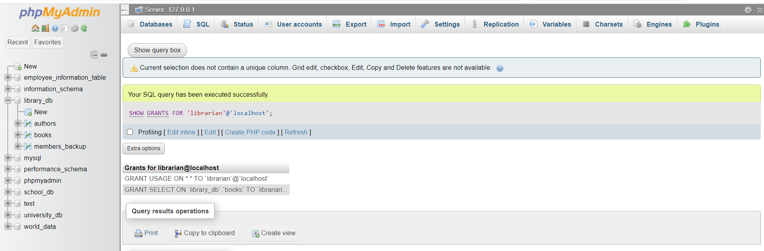
- You will no longer see INSERT privilege for library_db.book.

Lab 4: Revoke all permissions from user admin on the members table.
Answer:
Query: 1
REVOKE ALL PRIVILEGES ON library_db.members_backup FROM 'admin'@'localhost';
Query 2: run
SHOW GRANTS FOR 'admin'@'localhost';
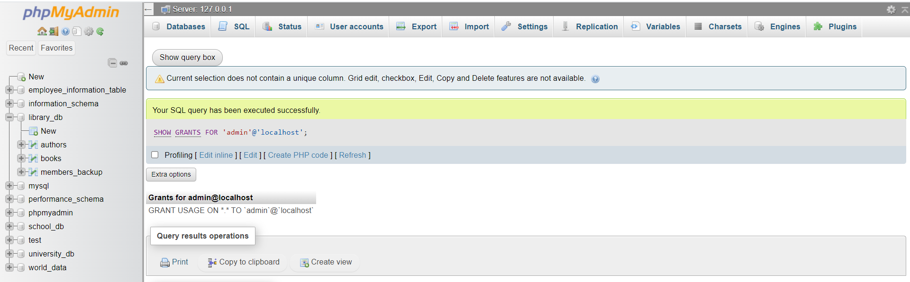
- You should see no privileges for the members_backup table.
13. Transaction Control Language (TCL)
Lab 3: Use COMMIT after inserting multiple records into the books table, then make another
insertion and perform a ROLLBACK.
Answer:
Query:
Step 1: Start transaction
START TRANSACTION;
Step 2: Insert multiple records
INSERT INTO books (book_id, title, author, publisher, year_of_publication, price)
VALUES
(201, 'Book A', 'Author A', 'Publisher A', 2018, 250),
(202, 'Book B', 'Author B', 'Publisher B', 2020, 300);
Step 3: Commit the transaction
COMMIT;
Step 4: Insert another record
INSERT INTO books (book_id, title, author, publisher, year_of_publication, price)
VALUES (203, 'Book C', 'Author C', 'Publisher C', 2021, 350);
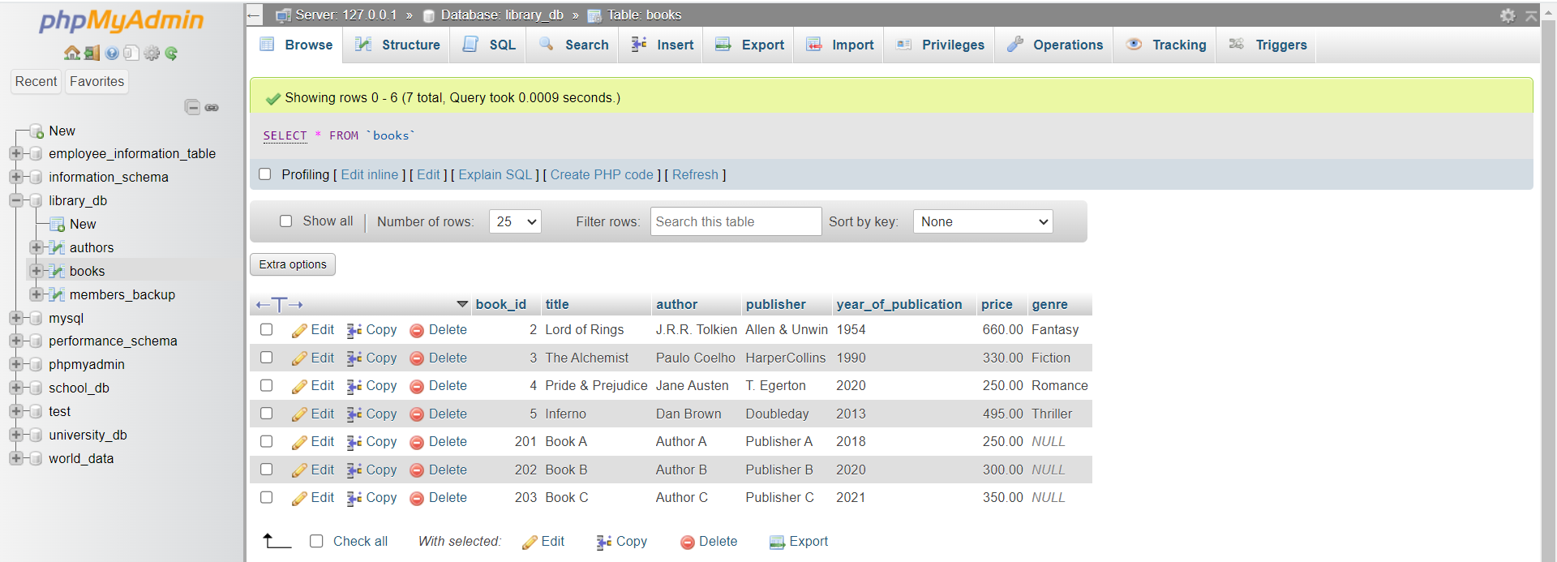

Step 5: Rollback
ROLLBACK;
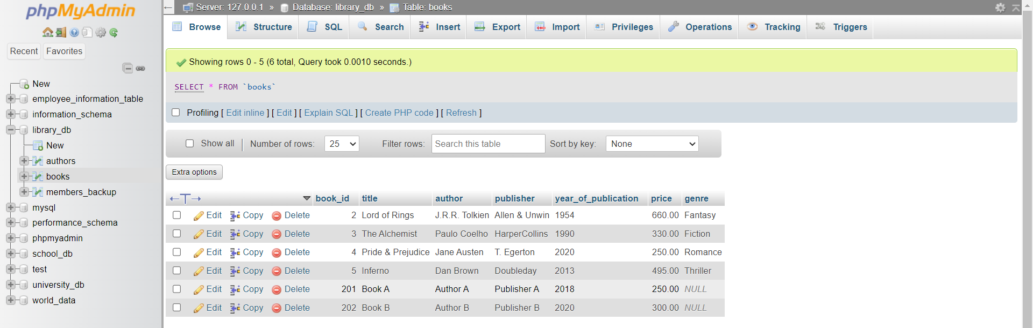
- Records 201 and 202 -> saved permanently.
- Records 203 -> not saved (because of rollback).

Lab 4: Set a SAVEPOINT before making updates to the members table, perform some
updates, and then roll back to the SAVEPOINT.
Answer:
Query:
Step 1: Start transaction
START TRANSACTION;
Step 2: Set a SAVEPOINT
SAVEPOINT sp_before_update;
Step 3: Perform updates
UPDATE members SET email = 'newemail1@example.com' WHERE member_id = 1;
UPDATE members SET member_name = 'Updated Name' WHERE member_id = 2;
Step 4: Roll back to SAVEPOINT
ROLLBACK TO sp_before_update;
Step 5: Commit final state
COMMIT;

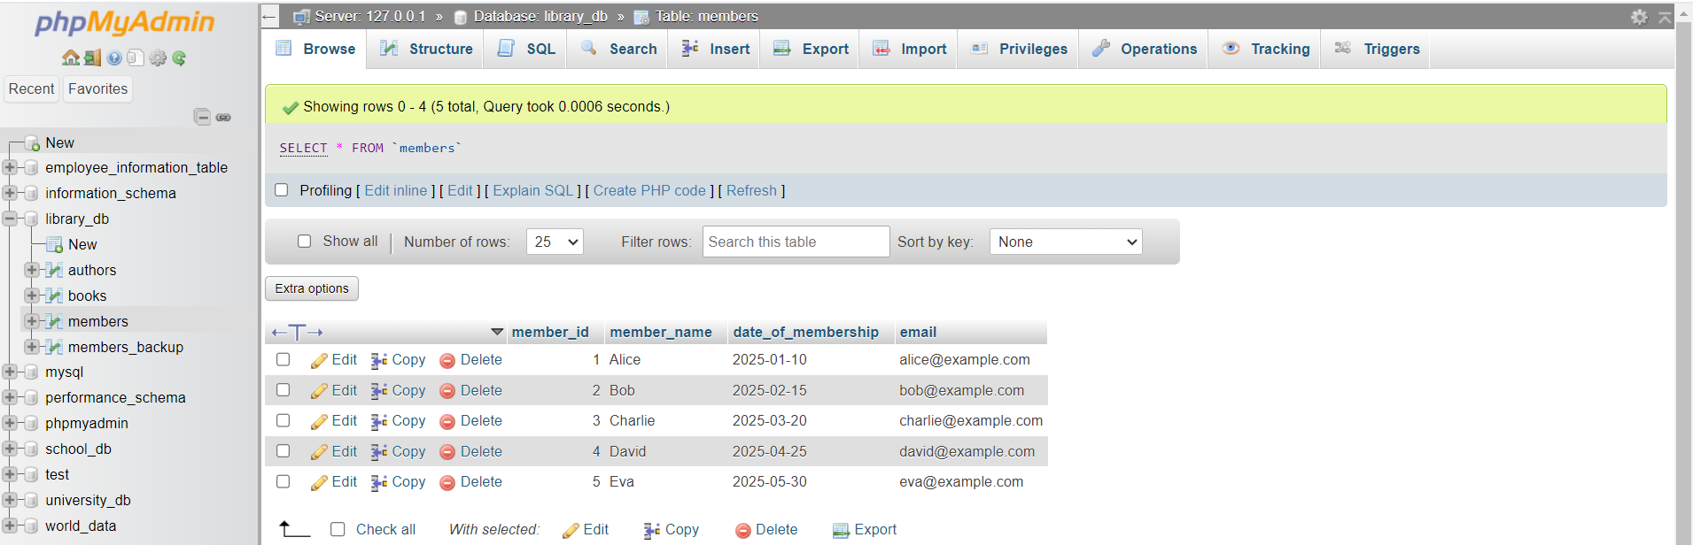
- Updates on member 1 & 2 -> Undone
- Database returns to the states at SAVEPOINT sp_before_update

14. SQL Joins
Lab 3: Perform an INNER JOIN between books and authors tables to display the title
of books and their respective authors' names.
Answer:
Query:
SELECT b.title, a.first_name, a.last_name FROM books b INNER JOIN authors a ON b.author_id = a.author_id;
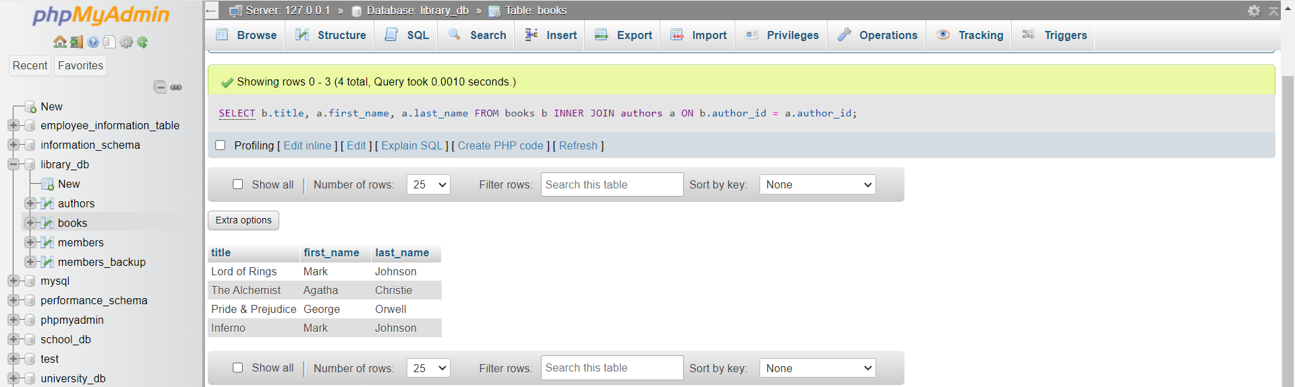

Lab 4: Use a FULL OUTER JOIN to retrieve all records from the books and authors tables,
including those with no matching entries in the other table.
Answer:
Query:
SELECT b.title, a.first_name, a.last_name FROM books b LEFT JOIN authors a ON b.author_id = a.author_id

UNION

SELECT b.title, a.first_name, a.last_name FROM books b RIGHT JOIN authors a ON b.author_id = a.author_id;
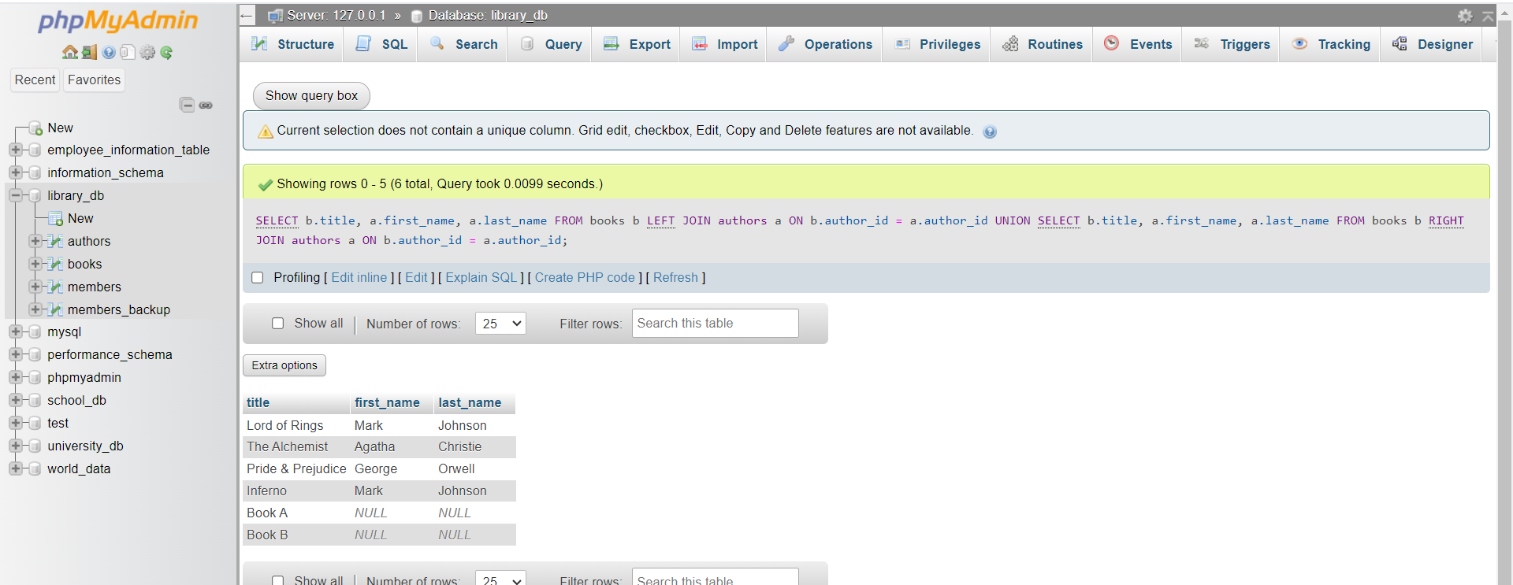

15. SQL Group By
Lab 3: Group books by genre and display the total number of books in each genre.
Answer:
Query:
SELECT
genre,
COUNT(*) AS total_books
FROM books
GROUP BY genre;
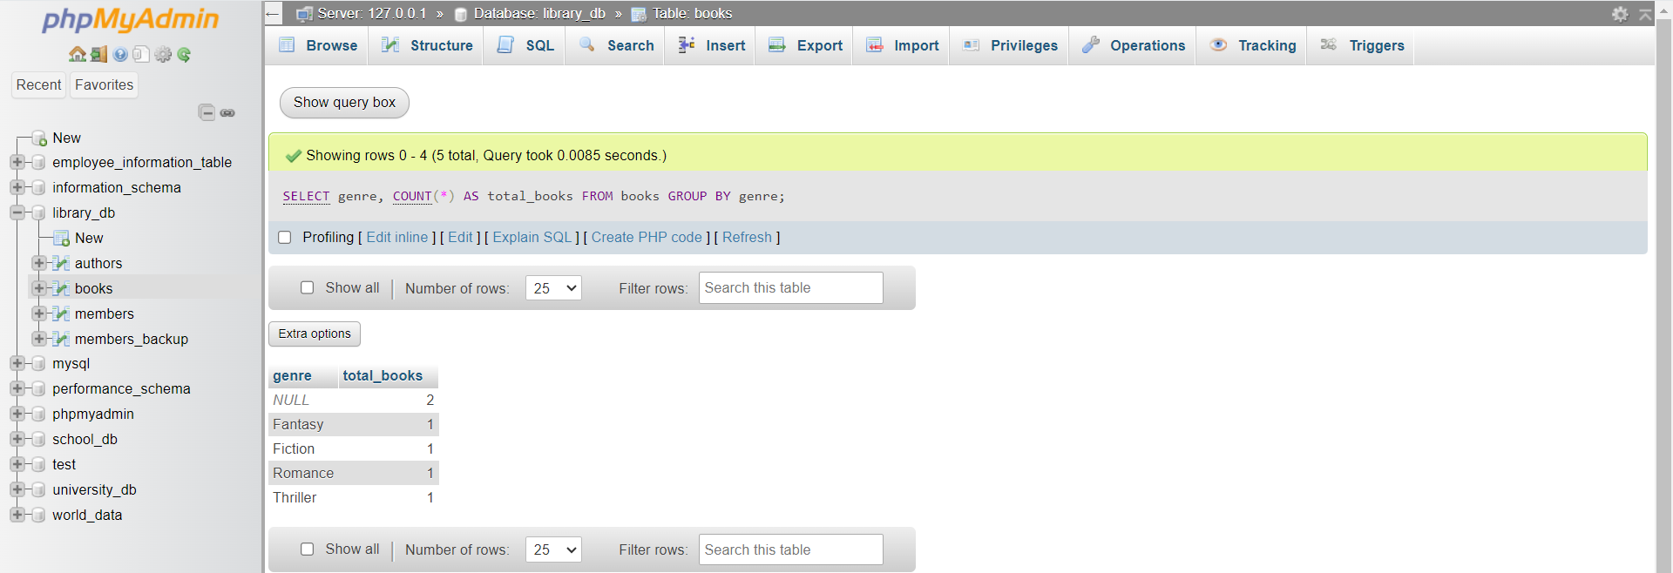

Lab 4: Group members by the year they joined and find the number of members who joined
each year.
Answer:
Query:
SELECT
YEAR(date_of_membership) AS join_year,
COUNT(*) AS total_members
FROM members
GROUP BY YEAR(date_of_membership);
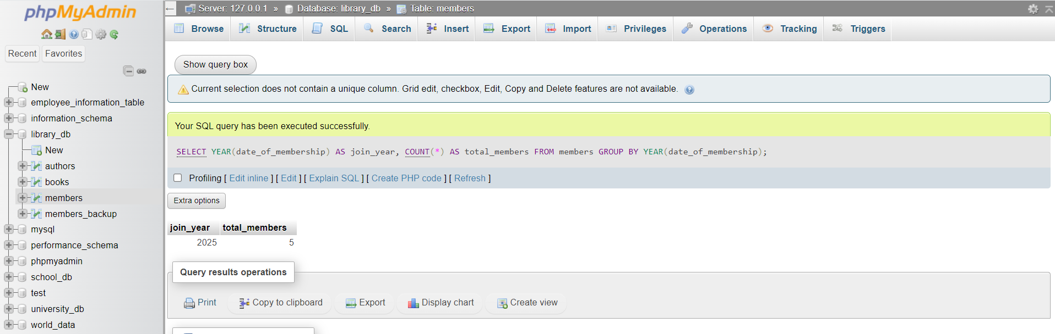

16. SQL Stored Procedure
Lab 3: Write a stored procedure to retrieve all books by a particular author.
Answer:
Query 1: Create the stored procedure
DELIMITER $$

CREATE PROCEDURE GetBooksByAuthor(IN authorName VARCHAR(100))
BEGIN
SELECT book_id, title, author, publisher, year_of_publication, price FROM books
WHERE author = authorName;
END $$

DELIMITER ;

Query 2: call (run) the stored procedure
CALL GetBooksByAuthor('J.K. Rowling');

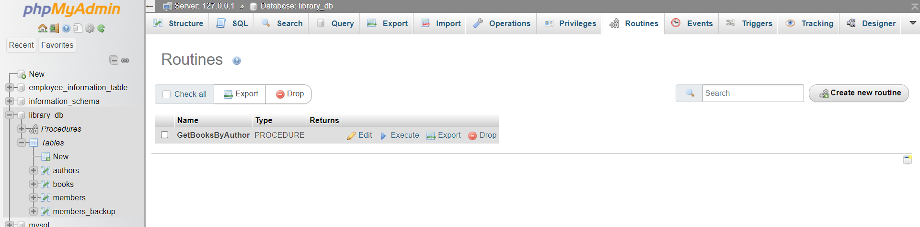

Lab 4: Write a stored procedure that takes book_id as an argument and returns the price
of the book.
Answer:
Query 1: stored procedure – getbookprice
DELIMITER $$

CREATE PROCEDURE GetBookPrice(IN p_book_id INT)
BEGIN
SELECT price
FROM books
WHERE book_id = p_book_id;
END $$

DELIMITER ;

Query 2: call (run) the stored procedure
CALL GetBookPrice(1);
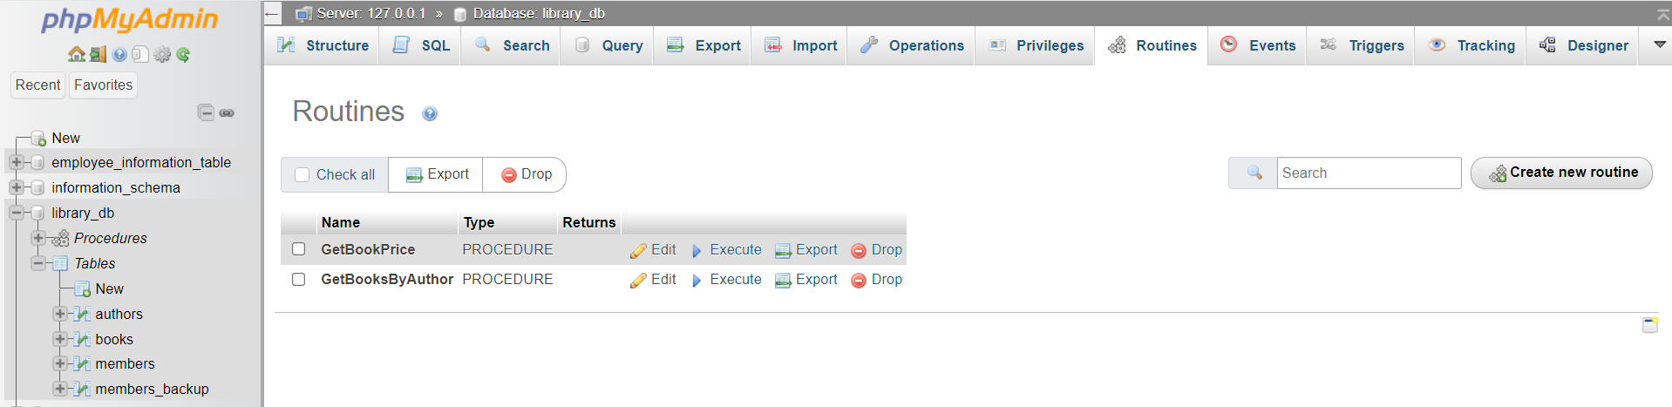

17. SQL View
Lab 3: Create a view to show only the title, author, and price of books from the books
table.
Answer:
Query 1: Create the View
CREATE VIEW book_summary AS SELECT title, author, price FROM books;
Query 2: To see the view
SELECT * FROM book_summary;
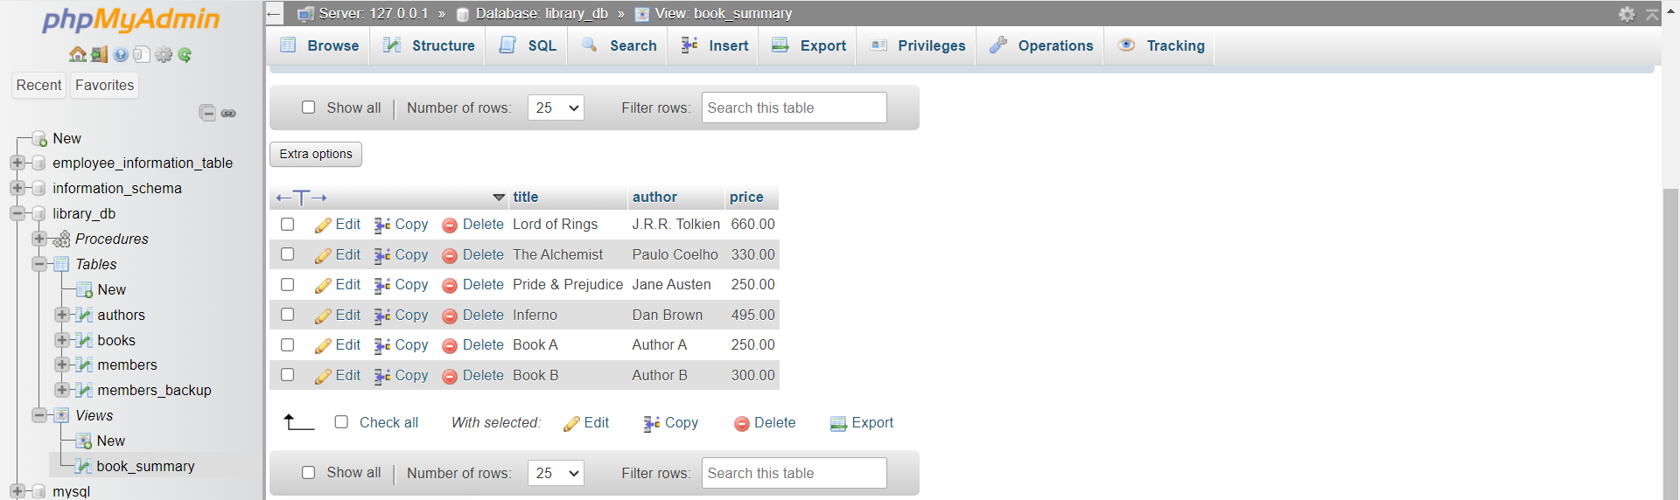

Lab 4: Create a view to display members who joined before 2020.
Answer:
Query 1: Create the View
CREATE VIEW members_before_2020 AS
SELECT member_id, member_name, date_of_membership, email FROM members
WHERE YEAR(date_of_membership) < 2020;
Query 2: To see the view
SELECT * FROM members_before_2020;
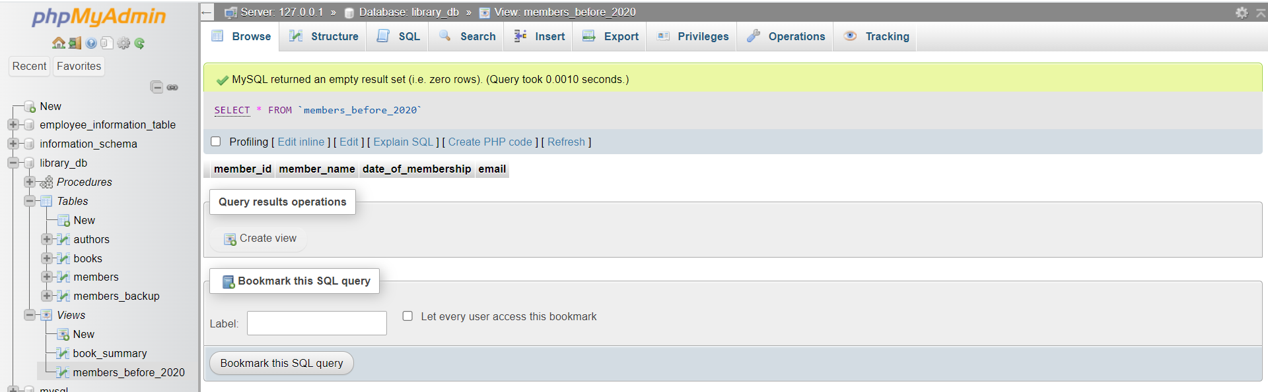
- No member joined before 2020 so rows are empty. All members joined on 2025.

18. SQL Trigger
Lab 3: Create a trigger to automatically update the last_modified timestamp of the
books table whenever a record is updated.
Answer:
Query:
Step 1: Make sure books table has last_modified column
ALTER TABLE books
ADD COLUMN last_modified TIMESTAMP DEFAULT CURRENT_TIMESTAMP ON UPDATE CURRENT_TIMESTAMP;
- This ensures last_modified is updated automatically on UPDATE, but we can also do it via trigger if needed.
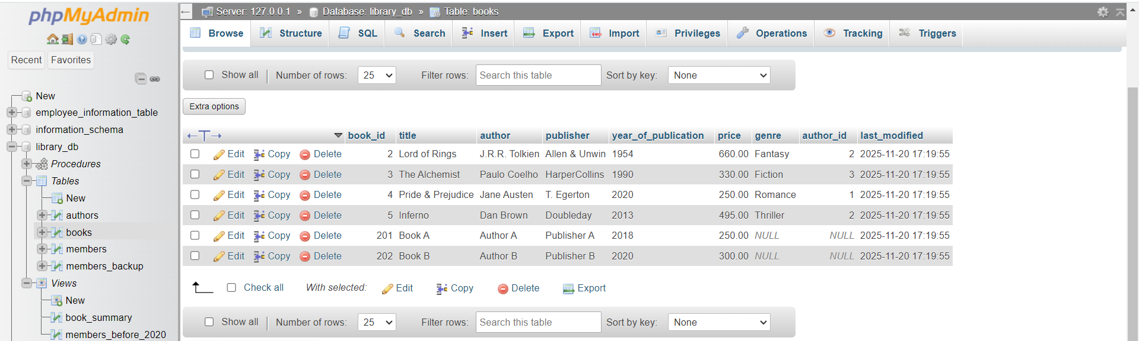

Step 2: Trigger to update last_modified on UPDATE
DELIMITER $$

CREATE TRIGGER update_books_timestamp
BEFORE UPDATE ON books
FOR EACH ROW
BEGIN
SET NEW.last_modified = NOW();
END$$

DELIMITER ;
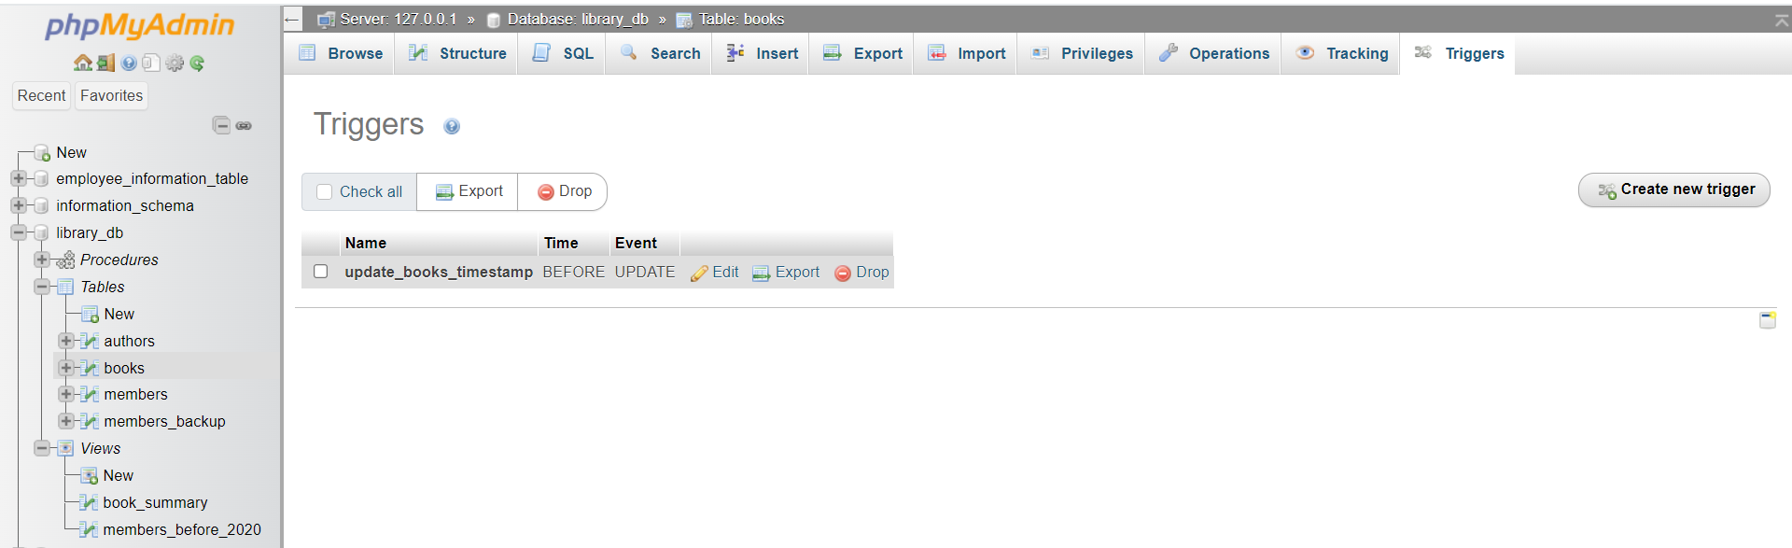

Lab 4: Create a trigger that inserts a log entry into a log_changes table whenever a
DELETE operation is performed on the books table.
Answer:
Query:
Step 1: Create log_changes table
CREATE TABLE log_changes (
log_id INT AUTO_INCREMENT PRIMARY KEY,
book_id INT,
title VARCHAR(100),
operation VARCHAR(10),
change_time TIMESTAMP DEFAULT CURRENT_TIMESTAMP
);
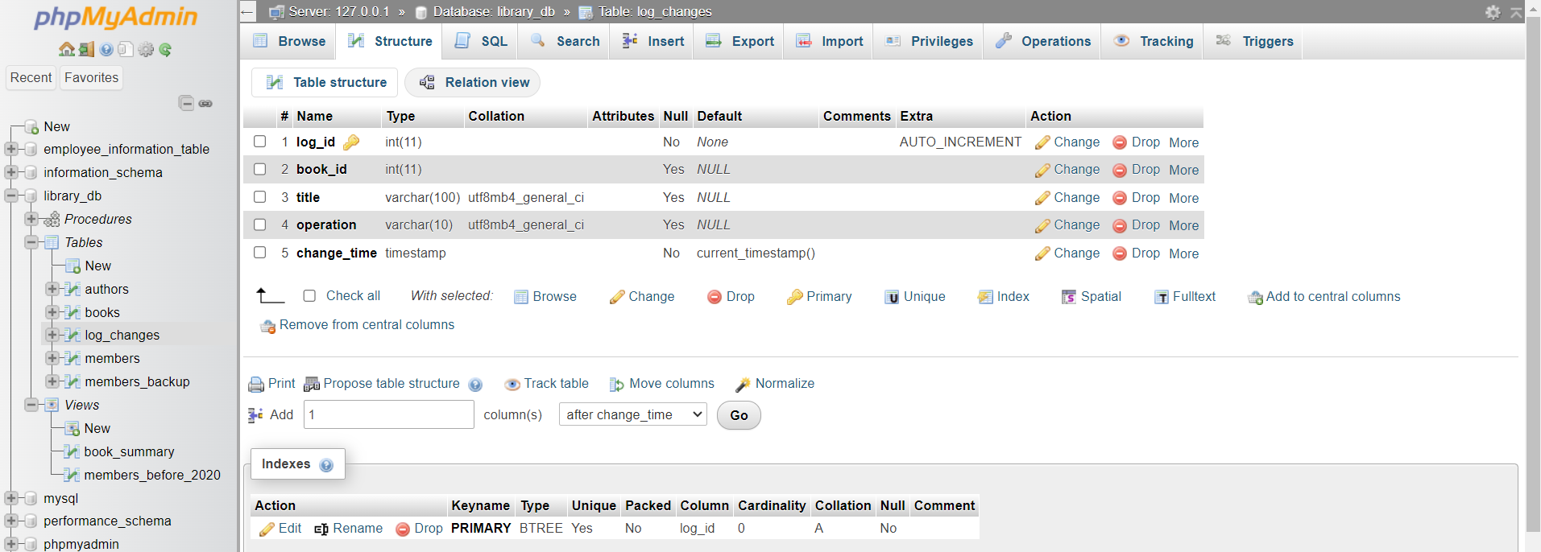

Step 2: Trigger to insert a log on DELETE
DELIMITER $$

CREATE TRIGGER log_books_deletion
AFTER DELETE ON books
FOR EACH ROW
BEGIN
INSERT INTO log_changes(book_id, title, operation)
VALUES (OLD.book_id, OLD.title, ‘DELETE’);
END$$

DELIMITER ;

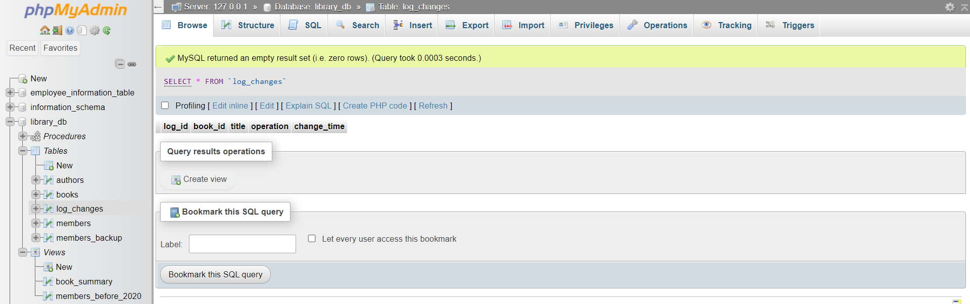

19. Introduction to PL/SQL
Lab 3: Write a PL/SQL block to insert a new book into the books table and display a
confirmation message.
Answer:
Query: Insert a new book and display confirmation
DELIMITER $$

CREATE PROCEDURE insert_book()
BEGIN
DECLARE v_book_id INT DEFAULT 6;
DECLARE v_title VARCHAR(100) DEFAULT 'The Great Gatsby';
DECLARE v_author VARCHAR(50) DEFAULT 'F. Scott Fitzgerald';
DECLARE v_publisher VARCHAR(50) DEFAULT 'Scribner';
DECLARE v_year INT DEFAULT 1925;
DECLARE v_price DECIMAL(10,2) DEFAULT 450;

-- Insert the new book
INSERT INTO books(book_id, title, author, publisher, year_of_publication, price)
VALUES(v_book_id, v_title, v_author, v_publisher, v_year, v_price);

-- Display confirmation
SELECT CONCAT('Book "', v_title, '" inserted successfully.') AS message;
END$$

DELIMITER ;

-- Call the procedure
CALL insert_book();
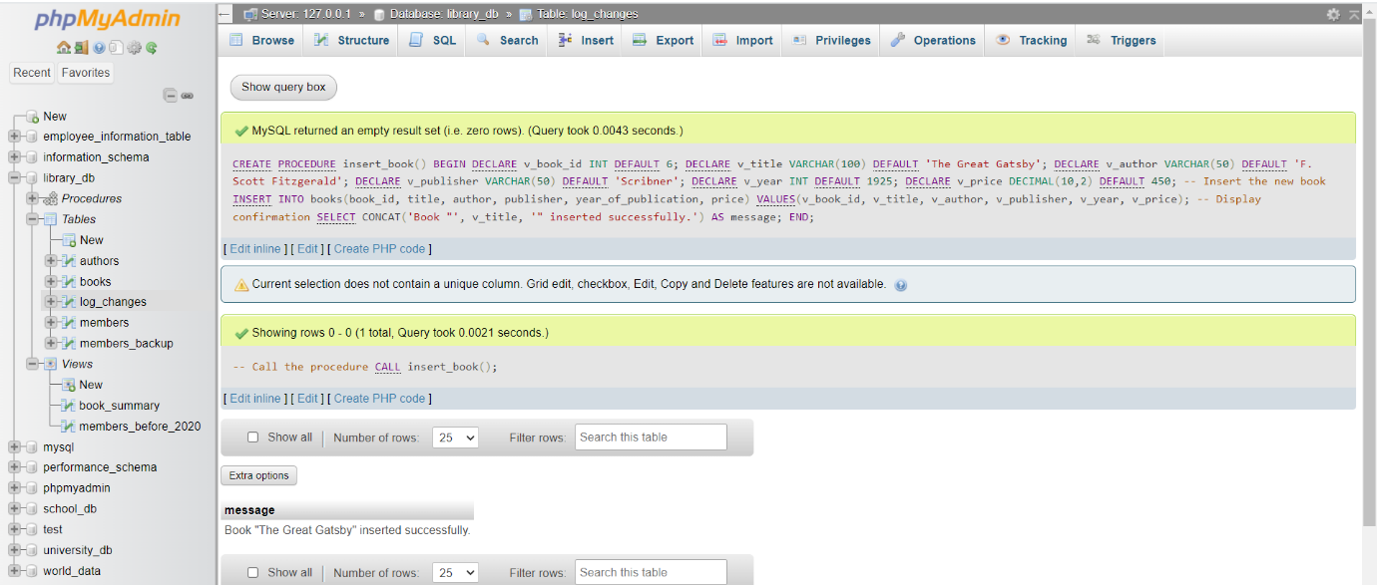

Lab 4: Write a PL/SQL block to display the total number of books in the books table.
Answer:
Query: Display total number of books
DELIMITER $$

CREATE PROCEDURE total_books()
BEGIN
DECLARE v_total_books INT;

-- Count total books
SELECT COUNT(*) INTO v_total_books FROM books;

-- Display total
SELECT CONCAT('Total number of books: ', v_total_books) AS message;
END$$

DELIMITER ;

-- Call the procedure
CALL total_books();
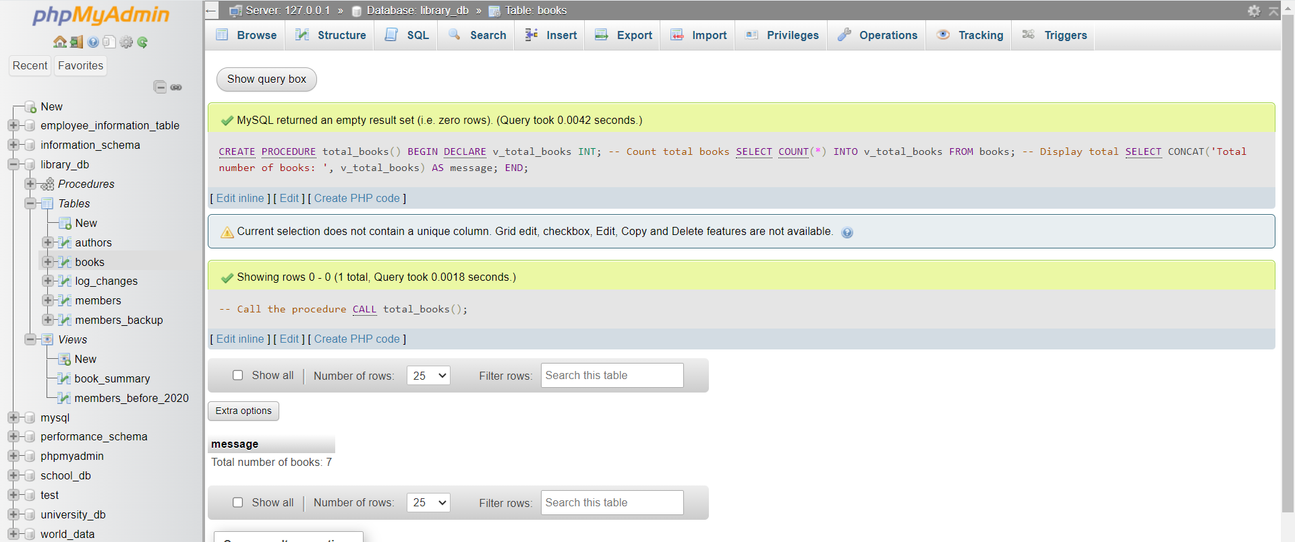

20. PL/SQL Syntax
Lab 3: Write a PL/SQL block to declare variables for book_id and price, assign values, and
display the results.
Answer:
Query: Declare variables for book_id and price, assign values, display results
DELIMITER $$

CREATE PROCEDURE lab3_variables()
BEGIN
-- Declare variables
DECLARE v_book_id INT;
DECLARE v_price DECIMAL(10,2);

-- Assign values
SET v_book_id = 101;
SET v_price = 499.99;

-- Display results
SELECT v_book_id AS Book_ID, v_price AS Price;
END$$

DELIMITER ;

-- Call the procedure
CALL lab3_variables();

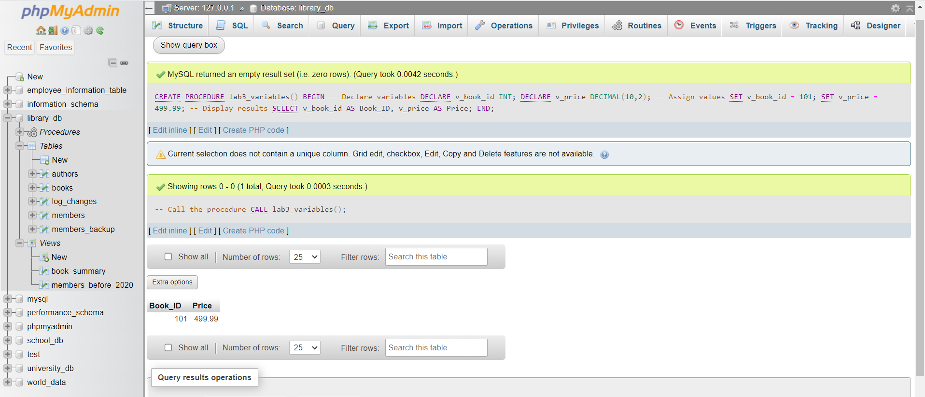

Lab 4: Write a PL/SQL block using constants and perform arithmetic operations on book
prices.
Answer:
Query: Using constants and arithmetic operations on book prices
DELIMITER $$

CREATE PROCEDURE lab4_constants()
BEGIN
-- Declare constants using user-defined variables (MySQL doesn't have true constants in procedures)
DECLARE price1 DECIMAL(10,2) DEFAULT 300;
DECLARE price2 DECIMAL(10,2) DEFAULT 450;

-- Perform arithmetic operations
DECLARE total_price DECIMAL(10,2);
DECLARE price_difference DECIMAL(10,2);

SET total_price = price1 + price2;
SET price_difference = price2 - price1;

-- Display results
SELECT price1 AS Price1, price2 AS Price2, total_price AS Total, price_difference AS Difference;
END$$

DELIMITER ;

-- Call the procedure
CALL lab4_constants();
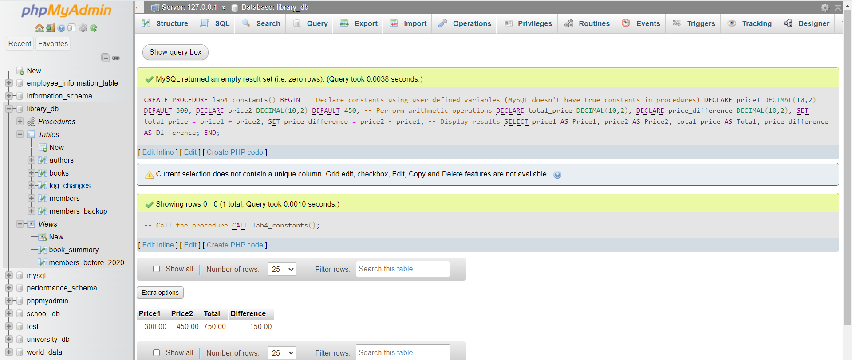

21. PL/SQL Control Structures
Lab 3: Write a PL/SQL block using IF-THEN-ELSE to check if a book's price is above $100
and print a message accordingly.
Answer:
Query: IF-THEN-ELSE to check book price
DELIMITER $$

CREATE PROCEDURE lab3_if_else(IN p_book_id INT)
BEGIN
DECLARE v_price DECIMAL(10,2);

-- Get the price of the book
SELECT price INTO v_price FROM books WHERE book_id = p_book_id;

-- IF-THEN-ELSE logic
IF v_price > 100 THEN
SELECT CONCAT('Book ID ', p_book_id, ' has a price above $100: $', v_price) AS message;
ELSE
SELECT CONCAT('Book ID ', p_book_id, ' has a price below or equal $100: $', v_price) AS message;
END IF;
END$$

DELIMITER ;

-- Example call
CALL lab3_if_else(1);
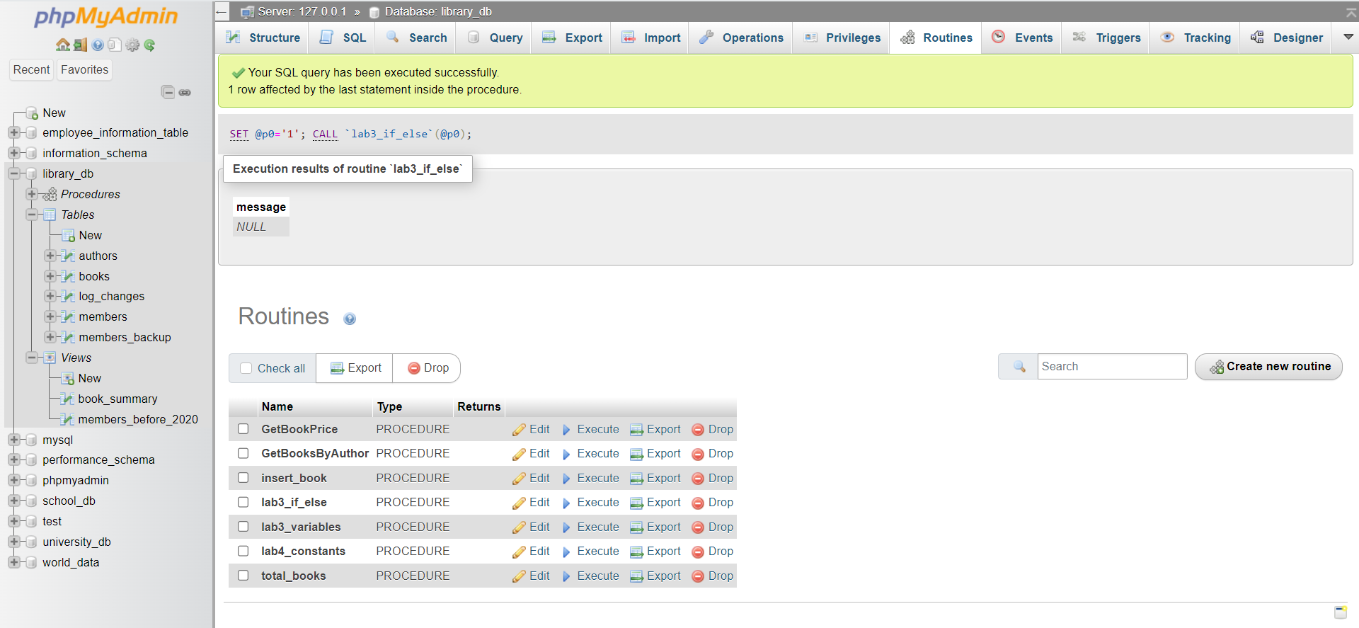

Lab 4: Use a FOR LOOP in PL/SQL to display the details of all books one by one.
Answer:
Query: FOR LOOP to display all book details
DELIMITER $$

CREATE PROCEDURE lab4_all_books()
BEGIN
-- Simply select all book details
SELECT book_id AS Book_ID,
title AS Title,
author AS Author,
publisher AS Publisher,
year_of_publication AS Year,
price AS Price
FROM books;
END$$

DELIMITER ;

-- Call the procedure
CALL lab4_all_books();
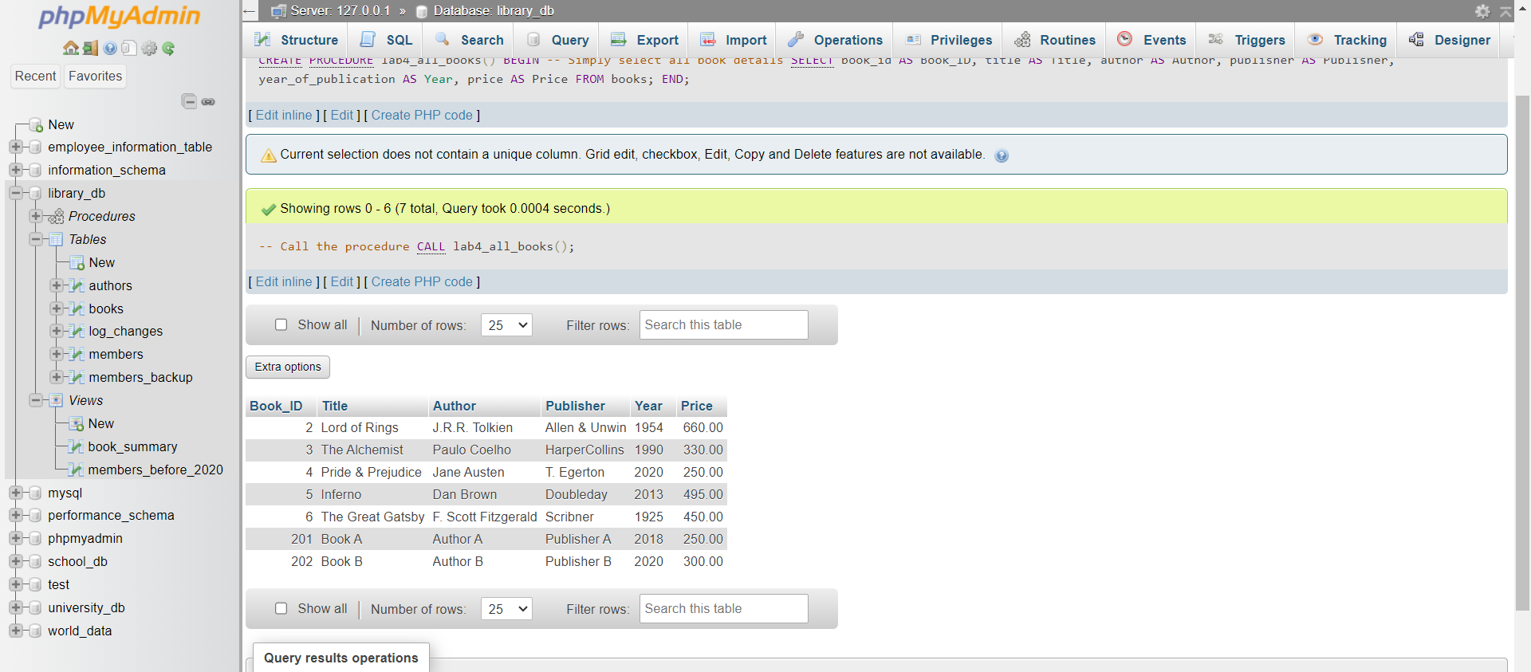

22. SQL Cursors
Lab 3: Write a PL/SQL block using an explicit cursor to fetch and display all records from the
members table.
Answer:
Query: Fetch and display all members using a cursor
Step 1: Stored Procedure
DELIMITER $$

CREATE PROCEDURE lab3_members_cursor()
BEGIN
-- Variables to hold member details
DECLARE v_member_id INT;
DECLARE v_member_name VARCHAR(50);
DECLARE v_date_of_membership DATE;
DECLARE v_email VARCHAR(100);
DECLARE done INT DEFAULT 0;

-- Cursor for all members
DECLARE cur_members CURSOR FOR
SELECT member_id, member_name, date_of_membership, email FROM members;

-- Handler to exit loop
DECLARE CONTINUE HANDLER FOR NOT FOUND SET done = 1;

OPEN cur_members;

read_loop: LOOP
FETCH cur_members INTO v_member_id, v_member_name, v_date_of_membership, v_email;
IF done THEN
LEAVE read_loop;
END IF;

-- Display member details
SELECT v_member_id AS Member_ID,
v_member_name AS Name,
v_date_of_membership AS Membership_Date,
v_email AS Email;
END LOOP;

CLOSE cur_members;
END$$

DELIMITER ;

Step 2: call the procedure
CALL lab3_members_cursor();
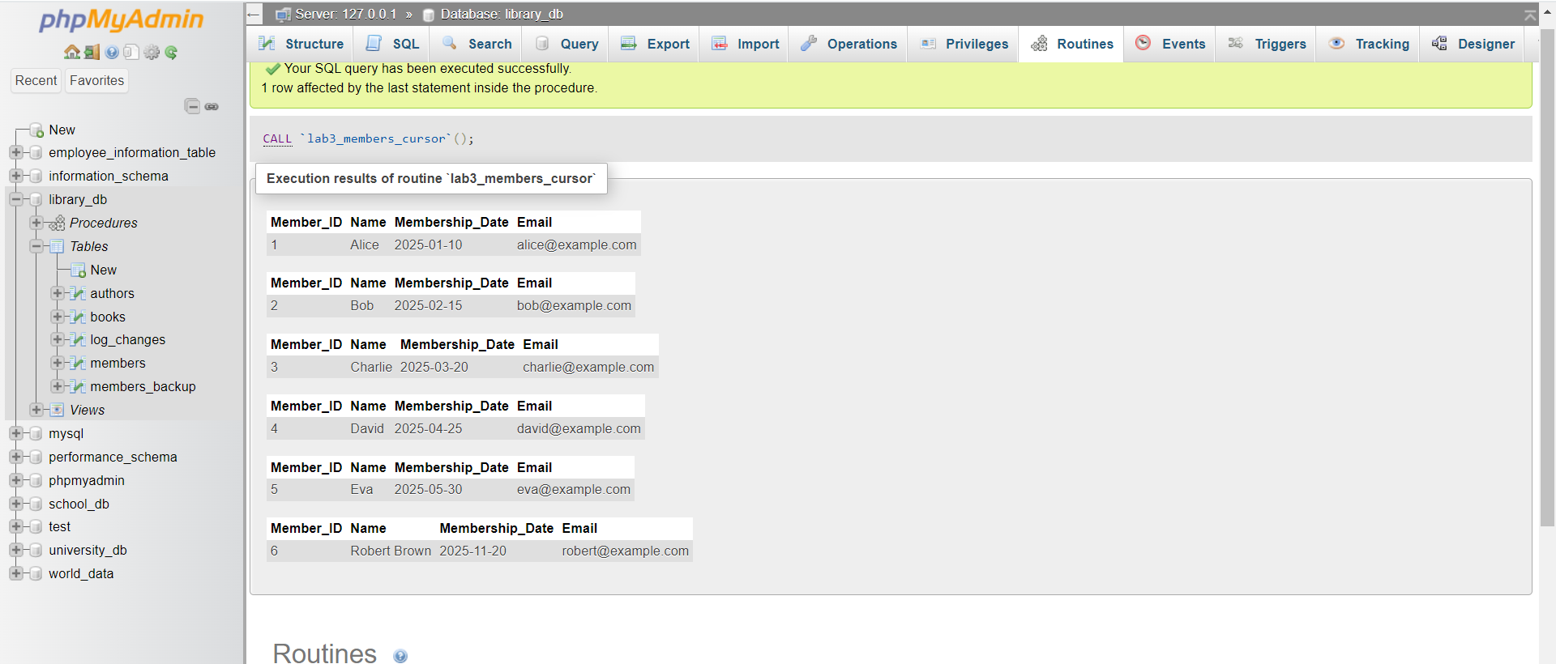

Lab 4: Create a cursor to retrieve books by a particular author and display their titles.
Answer:
Query: Retrieve books by a particular author using a cursor
Step 1: Stored Procedure
DELIMITER $$

CREATE PROCEDURE get_books_by_author(IN auth_name VARCHAR(100))
BEGIN
DECLARE done INT DEFAULT 0;
DECLARE b_title VARCHAR(100);

-- Cursor to select books by author
DECLARE book_cursor CURSOR FOR
SELECT title FROM books WHERE author = auth_name;

DECLARE CONTINUE HANDLER FOR NOT FOUND SET done = 1;

OPEN book_cursor;

read_loop: LOOP
FETCH book_cursor INTO b_title;
IF done THEN
LEAVE read_loop;
END IF;
SELECT b_title AS 'Book Title';
END LOOP;

CLOSE book_cursor;
END$$
DELIMITER ;

Step 2: Call the procedure
CALL get_books_by_author('Paulo Coelho');
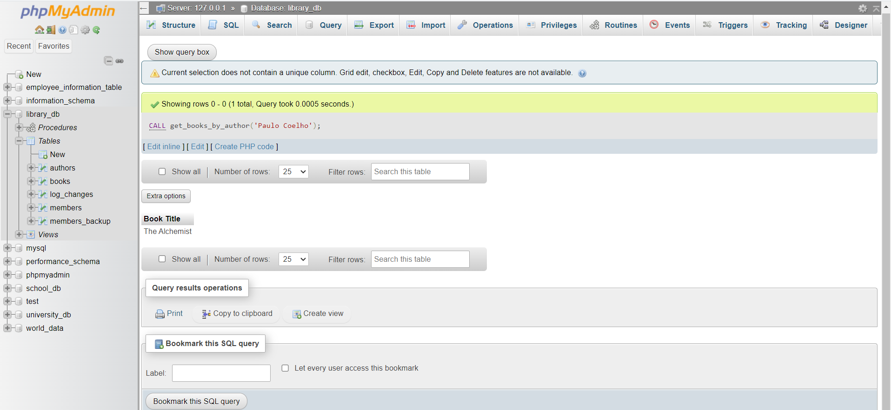

23. Rollback and Commit Savepoint
Lab 3: Perform a transaction that includes inserting a new member, setting a SAVEPOINT,
and rolling back to the savepoint after making updates.
Answer:
Query: Transaction with SAVEPOINT and ROLLBACK
Suppose we have a members table with columns:
member_id, member_name, date_of_membership, email

-- Start the transaction
START TRANSACTION;

-- 1️ Insert a new member
INSERT INTO members(member_id, member_name, date_of_membership, email)
VALUES (6, 'Robert Brown', '2025-11-20', 'robert@example.com');

-- 2️ Set a SAVEPOINT
SAVEPOINT before_update;

-- 3️ Update some records (example)
UPDATE members
SET member_name = 'Robert B.'
WHERE member_id = 6;

-- 4️ Rollback to the savepoint
ROLLBACK TO SAVEPOINT before_update;

-- 5️ Check the table state (SELECT)
SELECT * FROM members;

-- Optionally commit if everything is fine
COMMIT;
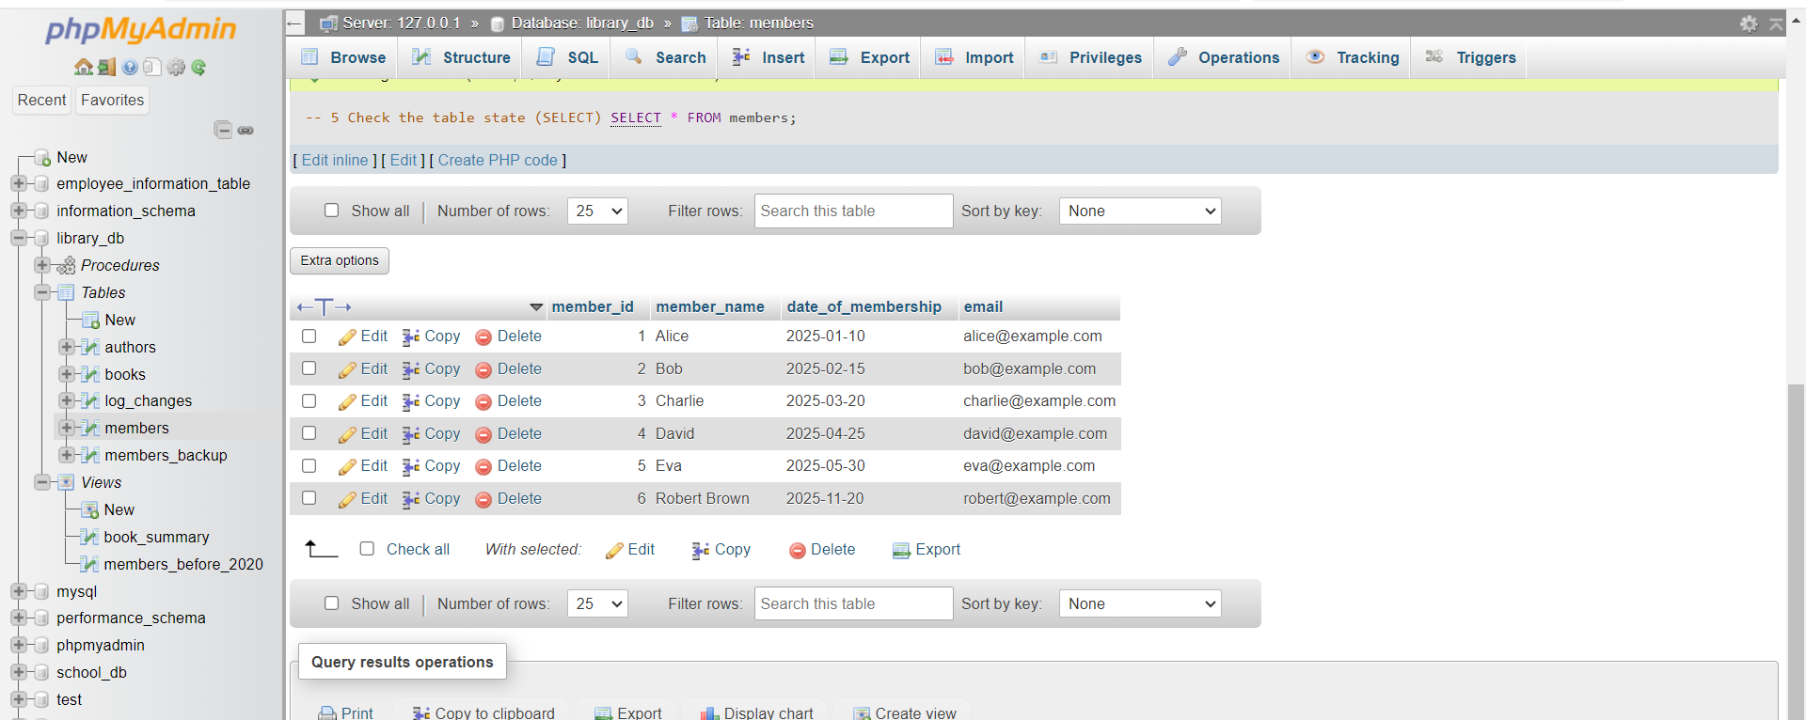

Lab 4: Use COMMIT after successfully inserting multiple books into the books table, then use ROLLBACK to undo a set of changes made after a savepoint.
Answer:
Query: COMMIT and ROLLBACK with multiple books
Suppose we have a books table:
book_id, title, author, publisher, year_of_publication, price

-- Start the transaction
START TRANSACTION;

-- 1️ Insert multiple books
INSERT INTO books(book_id, title, author, publisher, year_of_publication, price)
VALUES
(7, 'Pride and Prejudice', 'Jane Austen', 'T. Egerton', 1813, 350),
(8, '1984', 'George Orwell', 'Secker & Warburg', 1949, 400);

-- 2️ Commit the transaction (permanent)
COMMIT;

-- 3️ Start a new transaction
START TRANSACTION;

-- Make some changes
UPDATE books SET price = price + 50 WHERE book_id = 7;
UPDATE books SET price = price + 100 WHERE book_id = 8;

-- 4️ Set a savepoint
SAVEPOINT before_rollback;

-- Make additional changes
UPDATE books SET price = price * 2 WHERE book_id = 7;

-- 5️ Rollback to savepoint (undo last update only)
ROLLBACK TO SAVEPOINT before_rollback;

-- 6️ Check table state
SELECT * FROM books;

-- Commit final changes
COMMIT;
